EZReg

Jun Ma
Xu Xu
Nathan Plesnicher
Jerin Schneider
Chris Kennewick
Sharon Lin
Brian Watanabe

System Design Specification and Planning Document

Draft 1.0
4/22/2007

CSE 403 - CSRocks Inc.
Revisions
Version | Primary Author(s) | Description of Version | Date Completed
1.0 | Whole Team | first draft of system design specification | 04/22/07

System Architecture

Introduction
This part of the document provides a detailed definition of major components in our product. In the system architecture view and UML class diagram, we include the major modules in our system and how they interact with each other. The UML process diagrams outline the use cases we presented in the SRS. Since our application will connect to the UW database and will be used within the UW system, our database schema is based on the current UW course database. We will implement PHP for backend processing of search queries and communication with the UW database. We will use JavaScript to do all the scheduling on the front end. We plan to use CSS, HTML and JavaScript for all the layout as well as visual effects like roll-overs, ghosting, etc. We provide other alternatives and the reasons we chose current technologies in the end of this section. We made some assumptions when we developed our system architecture, but those are reasonable assumptions and we also have a very detailed risk assessment in our development plan.

System architecture view

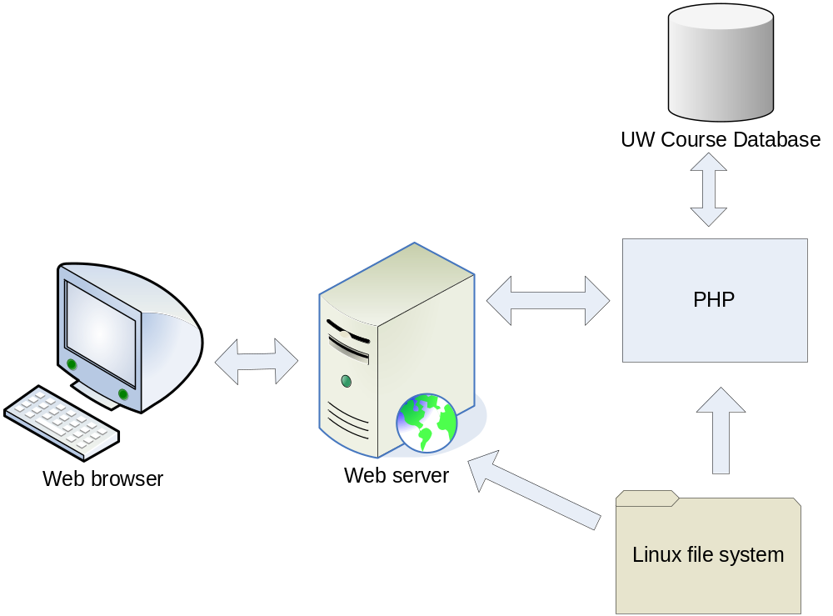

UML class diagram
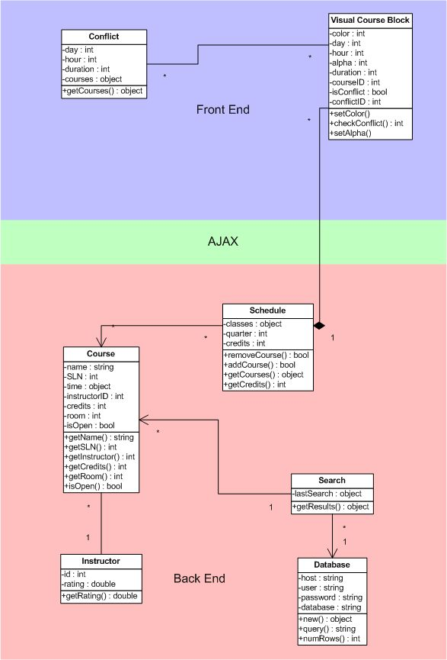

Process view – UML sequence diagrams

1. User searches a course

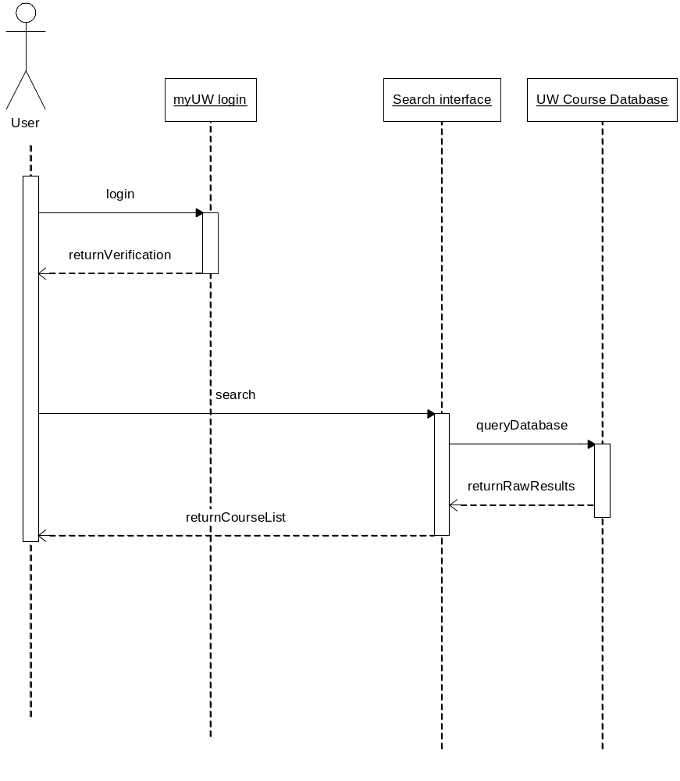

2.

Selected courses are reflected in the schedule
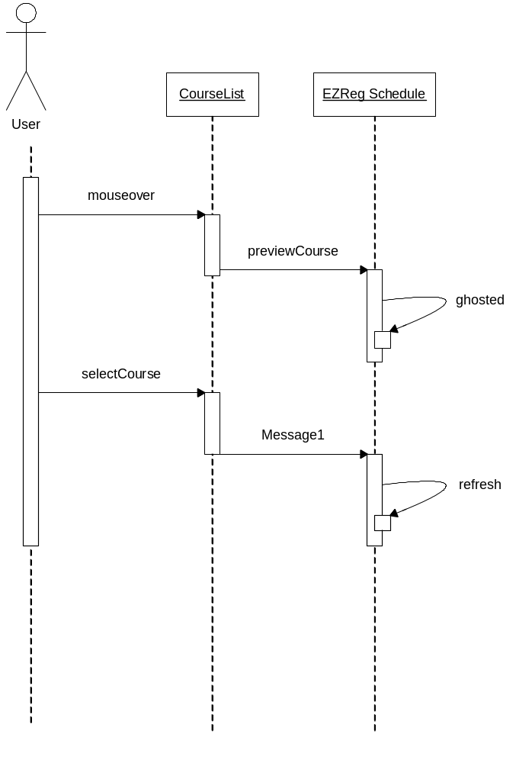

5. Database Schema
Below are the three tables (structure) that we will be accessing from the UW scheduling database. They contain information about courses, and the instructors that teach them.

dbo_sr_course_instr
Type | Attributes | key
fac_yr | smallint(6)
fac_qtr | smallint(6)
fac_seq_no | varchar(50)
fac_branch | smallint(6)
fac_course_no | smallint(6)
fac_meet_no | smallint(6)
fac_curric_abbr | varchar(6)
fac_sect_id | varchar(3)
fac_ssn | varchar(50)
fac_budget_no | int(11)
fac_updt_dt | datetime
fac_is_contact_hr | double
fac_is_enroll | smallint(6)
fac_enroll_10 | smallint(6)
fac_course_fte | double
fac_course_bgt | int(11)
fac_contact_hr | double
fac_wkld_pct | double
fac_name | varchar(30)
fac_updt_user_id | varchar(50) | Index
fac_descrip_url | varchar(24)
fac_spare_1 | varchar(10)
fac_spare_2 | varchar(10)
fac_spare_3 | varchar(10)
fac_spare_4 | varchar(10)
fac_hepps_val | tinyint(1)
fac_ts_print | tinyint(1)
fac_primary | tinyint(1)
fac_is_course | tinyint(1)
fac_web_updtd | tinyint(1)
sr_fac_field_6 | tinyint(1)
sr_fac_field_7 | tinyint(1)
sr_fac_field_8 | tinyint(1)

dbo_time_sched_meeting_times
Type | Attributes | key
ts_year | smallint(6)
ts_quarter | smallint(6)
course_branch | smallint(6)
course_no | smallint(6)
dept_abbrev | varchar(6)
section_id | varchar(3)
index1 | smallint(6)
days_of_week | varchar(6)
start_time | varchar(4)
end_time | smallint(6)
pm_indicator | varchar(1)
building | varchar(4)
room_number | varchar(8)
meeting_type | varchar(2)
schedule_25 | varchar(1)
r25_seq_num | smallint(6)
contact_hrs | double
contact_factor | double
prime_sect_id | varchar(3)
prime_meeting | tinyint(1)

dbo_time_schedule
Type | Attributes
ts_year | smallint(6)
ts_quarter | smallint(6)
course_branch | smallint(6)
course_no | smallint(6)
dept_abbrev | varchar(6)
section_id | varchar(3)
sln | smallint(6)
parent_sln | smallint(6)
institute | smallint(6)
room_cap | smallint(6)
l_e_enroll | smallint(6)
honors | smallint(6)
deduct_crs | smallint(6)
hyphenated | smallint(6)
time_mask_except | smallint(6)
maj_enroll | smallint(6)
non_maj_enroll | smallint(6)
stud_credit_hrs | double
maj_requests | smallint(6)
non_maj_requests | smallint(6)
current_enroll | smallint(6)
space_available | smallint(6)
space_avail_today | smallint(6)
space_avail_dt | datetime
students_added | smallint(6)
students_dropped | smallint(6)
students_denied | smallint(6)
auditors | smallint(6)
start_date | datetime
end_date | datetime
maj_enroll_10 | smallint(6)
non_maj_enr_10 | smallint(6)
stud_cred_hrs_10 | double
maj_requests_10 | smallint(6)
non_maj_req_10 | smallint(6)
add_codes_made | smallint(6)
add_codes_used | smallint(6)
drop_codes_made | smallint(6)
drop_codes_used | smallint(6)
add_codes_ord_1 | smallint(6)
add_codes_ord_2 | smallint(6)
drop_codes_ord_1 | smallint(6)
drop_codes_ord_2 | smallint(6)
add_pct_1 | smallint(6)
add_pct_2 | smallint(6)
drop_pct_1 | smallint(6)
drop_pct_2 | smallint(6)
students_no_prio | smallint(6)
tele_adds | smallint(6)
tele_drops | smallint(6)
dept_adds | smallint(6)
dept_drops | smallint(6)
regis_adds | smallint(6)
regis_drops | smallint(6)
ts_spare_1 | int(11)
ts_spare_2 | int(11)
ts_spare_3 | int(11)
ts_spare_4 | int(11)
ts_spare_5 | int(11)
energy_surcharge | double
fee_amount | double
fee_budget | int(11)
fee_type | smallint(6)
self_sustaining | tinyint(1)
trans_date_15 | datetime
writing_crs | tinyint(1)
english_comp | tinyint(1)
qsr | tinyint(1)
ts_research | tinyint(1)
ts_service | tinyint(1)
distrib_12 | tinyint(1)
vis_lit_perf_arts | tinyint(1)
indiv_society | tinyint(1)
natural_world | tinyint(1)
gen_elective | tinyint(1)
lecture_grd_sheet | tinyint(1)
course_evening | tinyint(1)
library_e_res | tinyint(1)
library_p_res | tinyint(1)
ts_osfa_inelig | tinyint(1)
sec_grade_sheet | tinyint(1)
ts_field_11 | tinyint(1)
ts_field_12 | tinyint(1)
ts_field_13 | tinyint(1)
ts_field_14 | tinyint(1)
ts_field_15 | tinyint(1)
ts_field_16 | tinyint(1)
sort_coll | varchar(1)
coll | varchar(1)
prior_branch | smallint(6)
prior_college | varchar(2)
prior_dept_abbrev | varchar(6)
prior_course_no | smallint(6)
prior_section_id | varchar(3)
course_content | varchar(1)
delete_flag | varchar(1)
section_type | varchar(2)
section_type_code | varchar(2)
dist_learn_type | smallint(6)
ts_dl_cal_type | smallint(6)
ts_dl_duration | smallint(6)
ts_admin_owner | smallint(6)
summer_term | varchar(1)
resp_college | varchar(2)
resp_branch | smallint(6)
resp_curric_abbr | varchar(6)
resp_course_no | smallint(6)
resp_sect_id | varchar(3)
with_branch | smallint(6)
with_dept_abbrev | varchar(6)
with_course_no | smallint(6)
with_section_id | varchar(3)
with_college | varchar(2)
joint_limit | smallint(6)
joint_curr_enroll | smallint(6)
joint_space_avail | smallint(6)
joint_sp_av_today | smallint(6)
credit_control | smallint(6)
credit_minimum | double
credit_maximum | double
credit_max_qtr | double
credit_this_qtr | double
course_title | varchar(20)
nmeet | smallint(6)
link_primary_sect | varchar(3)
l_e_indicator | varchar(1)
grading_system | varchar(1)
dup_enroll_allow | varchar(1)
srs_comment | varchar(50)
crse_time_mask | varchar(30)
fee_rev_obj_cd | varchar(6)
ts_course_url | varchar(80)
ts_spare_6 | varchar(10)
ts_spare_7 | varchar(10)
ts_spare_8 | varchar(10)
ts_spare_9 | varchar(10)
ts_spare_10 | varchar(10)
final_exam_flg | smallint(6)
final_exam_dt | datetime
final_exam_start | smallint(6)
final_exam_end | smallint(6)
final_exam_bldg | varchar(4)
final_exam_room | varchar(8)
final_exam_seq_no | smallint(6)
starting_time | varchar(4)
day_of_week | varchar(6)
ending_time | varchar(4)
pm_flag | varchar(1) | Fulltext

6. Design Alternatives and/or Assumptions

Alternate Designs:

We could have used ASP rather than PHP for the architecture; however, we chose PHP due to there being more in-group experience with PHP. It also has less overhead and more online documentation. Also PHP is more widely accepted as it is open source.

We could have used Microsoft SQL server for the database; however, MySql is more widely accepted as being open source. Also, MySql integrates more seamlessly with PHP.

Assumptions:

We are assuming that we can change the databases that UW gave to us by adding course descriptions and full titles to the database.

We’re assuming that UW developers will be able to migrate from our PHP/MySql to the homebrew database that UW has with a COM interface to it.

We’re assuming that Javascript will be able to cover all of the features that we need it to cover.
Development Plan

Team Structure
Title | Main responsibilities | Member
Back end developer | - Manipulation of the Database,  - Back end PHP support for front end Javascript | Jerin Schneider  Ellen Xu  Brian Watanabe
Front end developer | - Integration of AJAX framework into the project  - Front end Javascript interaction with the PHP back end  - Search pane  - Front end Javascript effects | Nathan Plesnicher  Chris Kennewick  Jun Ma  Sharon D. Lin
Program manager | - Oversee the project and coordinate between subgroups | Ellen Xu
Dev/Test | - Automation for testing/managing bugtracking | Jun Ma

Project Schedule
Date | Milestone | Target Completion
4/25/07 | Internal | Back end Developers:  - SQL database set up  - PHP/AJAX support on the backend installed  - Get the necessary information from the UW database  - Identify problem areas in the database and how to effectively use SQL to join the databases  Front end Developers:  - Read up on Javascript/Website skeleton  - Get rough prototype for front end UI  Test/Dev  - Set up Bugzilla Database  - Start setting up test website  - Read up on JSUnit for some insight on how to test Javascript
4/29/07 | Internal | Back end Developers:  - Get course descriptions into the backend database  - Get SQL query support together for the Front end to use  Front end Developers:  - UI at a usable state  - Queries possible from the front end to the back end  Front end/Back end Integration  Test Dev:  - Test website put together  - Test Automation at a usable level  - Implement JSUnit, if advantageous.
5/5/07 | Internal | Whole Team:  - Bugs that block beta feature fixed (Beta feature complete)  - Hold a usability session with the customer
5/10/07 | Beta | Beta features completed and release to customers for usability feedback
5/15/07 | Internal | Developers (Front/Back):  - Usability Bugs fixed  - Useful Beta feedback Integrated into product  Dev/Test:  - Help fix usability/other bugs and work on automation
5/20/07 | Internal | Whole Team:  - Finish up core final features  - Start work on long term or stretch features  - Maybe have a Beta refresh
5/25/07 | Internal | Whole Team:  - Final release feature complete  - Test and clean up of bugs
5/30/07 | Final | Final Product Release.

Risk Assessment

Risk | Chance of occurring (H,M,L) | Impact if it occurs (H,M,L) | Steps taking to increase chance it won’t occur | Mitigation plan should it occur
UW database too unwieldy to use effectively | Med | High | - Identify problem areas in the databases early  - Ask questions to the UW database administrators when problems arise | - Cut features that may require a more organized database structure  - Attempt to organize the database ourselves
Refreshing front page may be too slow due to either database or javascript limitations | Low | Med | - Optimize the algorithms and queries used to query the SQL database | - If the database is slower: modify the database or optimize the search algorithms, maybe prejoin the tables before any search is run on it  - If the code is slow: modify the code
AJAX integration proves more difficult than anticipated | Med | Med | - Developers need to learn AJAX early and identify the limitations and the advantages of using it. | - Cut AJAX support and move to brute Javascript/PHP  - Modify the project architecture to account for the limitations of AJAX
UW changes the registration ASP script that we are depending on to register our classes | Low | High | - Maintain communications with UW to preempt the script changes. | - Use an old copy of the registration script that works with our project
Customer changes requirements for the UI | Low | High | - Hold usability sessions with the customer frequently, maybe once before beta. | - Make necessary changes to fix the usability with surgical changes to the overall architecture.

Test and Documentation Plan

Test Plan
- Unit Test Strategy
  - This will test component functionality of our product
    - SQL queries
    - Front end Javascript components
    - Back end PHP components
  - Tests will be developed by the entire team conducting small code reviews
  - Unit tests should be run before integration of a component and ideally every day.
- System Test Strategy
  - This will test end to end functionality of the product, namely the integration of the front end UI to the back end SQL queries
  - The tests will be developed using the use case scenarios that we have written up.
  - System tests will be run whenever a new component is integrated into a stable system.
- Usability Test Strategy
  - This will test if the UI is intuitive and easy to use by our customer(s)
  - The tests will be developed through our use cases and asking the customer to run through them.
  - Obtaining real time feedback on the UI
  - This will be run every release and maybe on feature complete dates
- Adequacy of Test Strategy
  - The adequacy of our test strategy will be determined by customer satisfaction during the usability tests.
  - A tentative code coverage strategy for our product will be examined as another possible metric for test coverage.
- Bug Tracking Mechanism and Plan of Use
  - Bugzilla use is planned for filing and resolving issues
  - Specification issues as well as code bugs will be captured in Bugzilla

Documentation Plan
An online user guide that will explain the main functionality of the product will be linked from the product.

Planned functionality to be covered on the user guide:
- A walkthrough of a typical search, find, and register process
- Tips on how to resolve conflicts in the schedule
- Tips on how to most effectively search for classes
- Detailed descriptions on the search criteria that we offer
- Description of the relationship between the manipulation of the search option and the visual schedule

There is also a tentative plan to implement some sort of on-screen help display feature for the final release of the product. This is a stretch feature, and it’s actual execution will depend factors such as time and compatibility with the rest of the project.

