PayBack™

Max Aller, Douglas Copas, Chen Lee, Alex Odle, Jason Salameh, Ian Stuiksma

Software Requirements
Specification

Draft 1
Date April 13th 2007

CSE 403 - CSRocks Inc.
Revisions
Version | Primary Author(s) | Description of Version | Date Completed
1 | Max Aller, Alex Odle, Jason Salameh, Ian Stuiksma, Douglas Copas, Chen Lee | Initial SRS discussion | 04/13/07

Overall Description

Description

PayBack™ is an online service for roommates looking to organize and consolidate communal expenditures with one easy to use tool. Users have the ability to add everyday expenses like groceries and home improvement items. In addition, users can integrate recurring bills with powerful customization features including the option to set exact or relative amounts owed by each roommate for a particular bill. Users are then able to “PayBack” another roommate the amount owed through PayPal, or send email reminders to other roommates about amounts owed.

PayBack™ is targeted towards any household where two or more roommates share expenses. Anyone who has dealt with this situation can attest that it often becomes a hassle to coordinate the expenses of the house. In many situations one unfortunate roommate will be assigned as the “home accountant” and will waste hours of his time calculating the balances of each person and tracking them down, ensuring that he or she actually pays what they owe. PayBack™ virtually eliminates the need for that person, doing all that work and more.

Considering the breadth of its target, consumer PayBack™ will be capable of supporting a high volume of users. Users will register for a free account on our website which gives them the ability to create a “household”. All the other roommates can now register and join the household in order to get started.

The public documentation that will be included with this product will be an FAQ page and a tour of the PayBack™ website. The FAQ page will be easy for the user to find and will include common questions about our service and how it should be used. The site tour will be targeted to new users and will give a sequence of screen shots and explanations on how to use our website. In addition to the public documentation, our code will be well commented, and will come packaged with an overview document

Scope

The PayBack™ system will not pay your bills for you, nor will it give you financial advice. PayBack™ will provide a service for roommates to keep track of their expenses easily and efficiently.

The main database backbone will be developed in Microsoft’s SQL, from there will be an IIS server running on top of Windows Server 2003. The actual web application will be developed in C#,ASP.net, HTML and AJAX. There might be some scalability issues that can be addressed with more/bigger/faster servers.
Use Cases

Use case UML Diagram

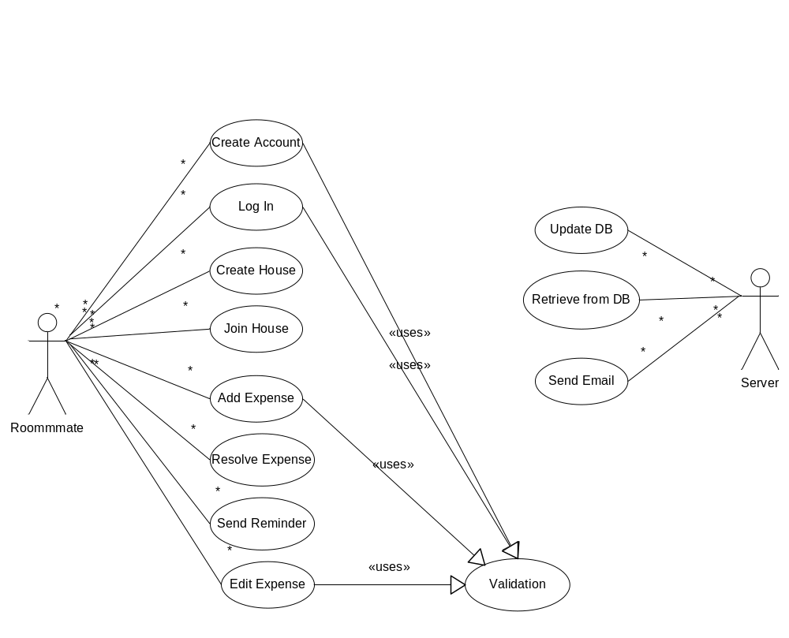

Formal Use case 1

Goal | Pay back a roommate
Level | User
Primary Actor | Roommate
Precondition | Roommate is registered with a household  Roommate has debt (negative balance) to pay back
Success end condition | Roommate pays debt back
Failure end condition | Roommate cannot pay debt back
Trigger | Roommate logs onto the site
Main success scenario | 1. Roommate enters username and password  2. System verifies and logs Roommate in  3. System directs Roommate to “Home” screen  4. Roommate selects the “Roommates” tab  5. System changes to “Roommates” screen  6. Roommate checks the box next to the roommate they wish to pay, then selects the “Pay Back” button  7. System validates user input and directs Roommate to confirmation page.  8. Roommate confirms payment.  9. System sends email notification to user and recipient.  10. System redirects user to Roommates tab with notification of success
Extensions | 2a. Password is incorrect  2a.1 System redirects to login screen (with error)  2a.2 Roommate tries again or presses Forgot Password  2b. Roommate does not have an account  2b.1 System redirects to login screen (with error)  2b.2 Roommate registers account  6a. Roommate does not select a roommate to PayBack  6a.1 System show dialog box warning “No Roommate Checked”  7a. Roommate input is invalid  7a.1 Roommate is reminded of what valid input is
Variations | 4’. Roommate select “Pay Back” from the “reminders” position on homepage  4’.1 Redirected to Roommates tab  6’. Roommate has a positive balance with the selected roommate  6’.1 System redirects to screen to enter additional information in the email to be sent  6’.2 Roommate selects “Send Reminder”  6’.3 System shows conformation screen  6’’. Roommate clicks “+” next to other roommate name to expand specific information with roommate  6’’.1 System expands menu with specifics  6’’.2 Roommate checks the specific expenses they wish to include

Formal Use case 2

Goal | Add an expense
Level | User
Primary Actor | Roommate
Precondition | Roommate is part of a house
Success end condition | Expense is added
Failure end condition | Expense is not added
Trigger | Roommate logs on to website
Main success scenario | - Roommate enters user name and password  - System verifies and logs roommate in  - System directs roommate to Home  - User clicks on Expenses tab  - User clicks Add Expense  - System opens Add Expense bubble  - User enters Due Date, Description, Amount and clicks Add  - System validates input  - System adds expense to database with default settings  - System reloads page to updates Active Expenses table
Extensions | 2a. Password is incorrect  2a.1 System redirects to login screen (with error)  2a.2 Roommate tries again or presses forgot password  2b. User does not have an account  2b.1 System redirects to login screen (with error)  2b.2 User registers account  8a. User enters invalid input  8a.1 System adds error message on Add Expense bubble
Variations | 7’. User clicks Detailed link on Add Expense bubble  7’.1 System redirects user to Detailed Add Expense page  7’.2 Roommate fills in detailed expense info  7’.3 Roommate clicks Add Expense

Feature List
Feature | Target
Roughed out UI | Beta 1
User accounts | Beta 1
Manage (add/remove) expenses and debts | Beta 1
Manage houses | Beta 1
Admin functionality | Beta 1
Send and receive alerts (reminders) | Beta 2
Add expense bubble | Beta 2
Filter option for expense page | Beta 2
Personal notes on homepage | Beta 2
User messaging | Beta 2
Filter displayed expenses | Beta 2
Refined user interface | Final
Full documentation | Final
Reliable and without bugs | Final
Pictures and user profiles | Final
Paypal support | Final
Tooltips | Stretch
SmartBalance™ | Stretch

UI Prototype

Login Home Page
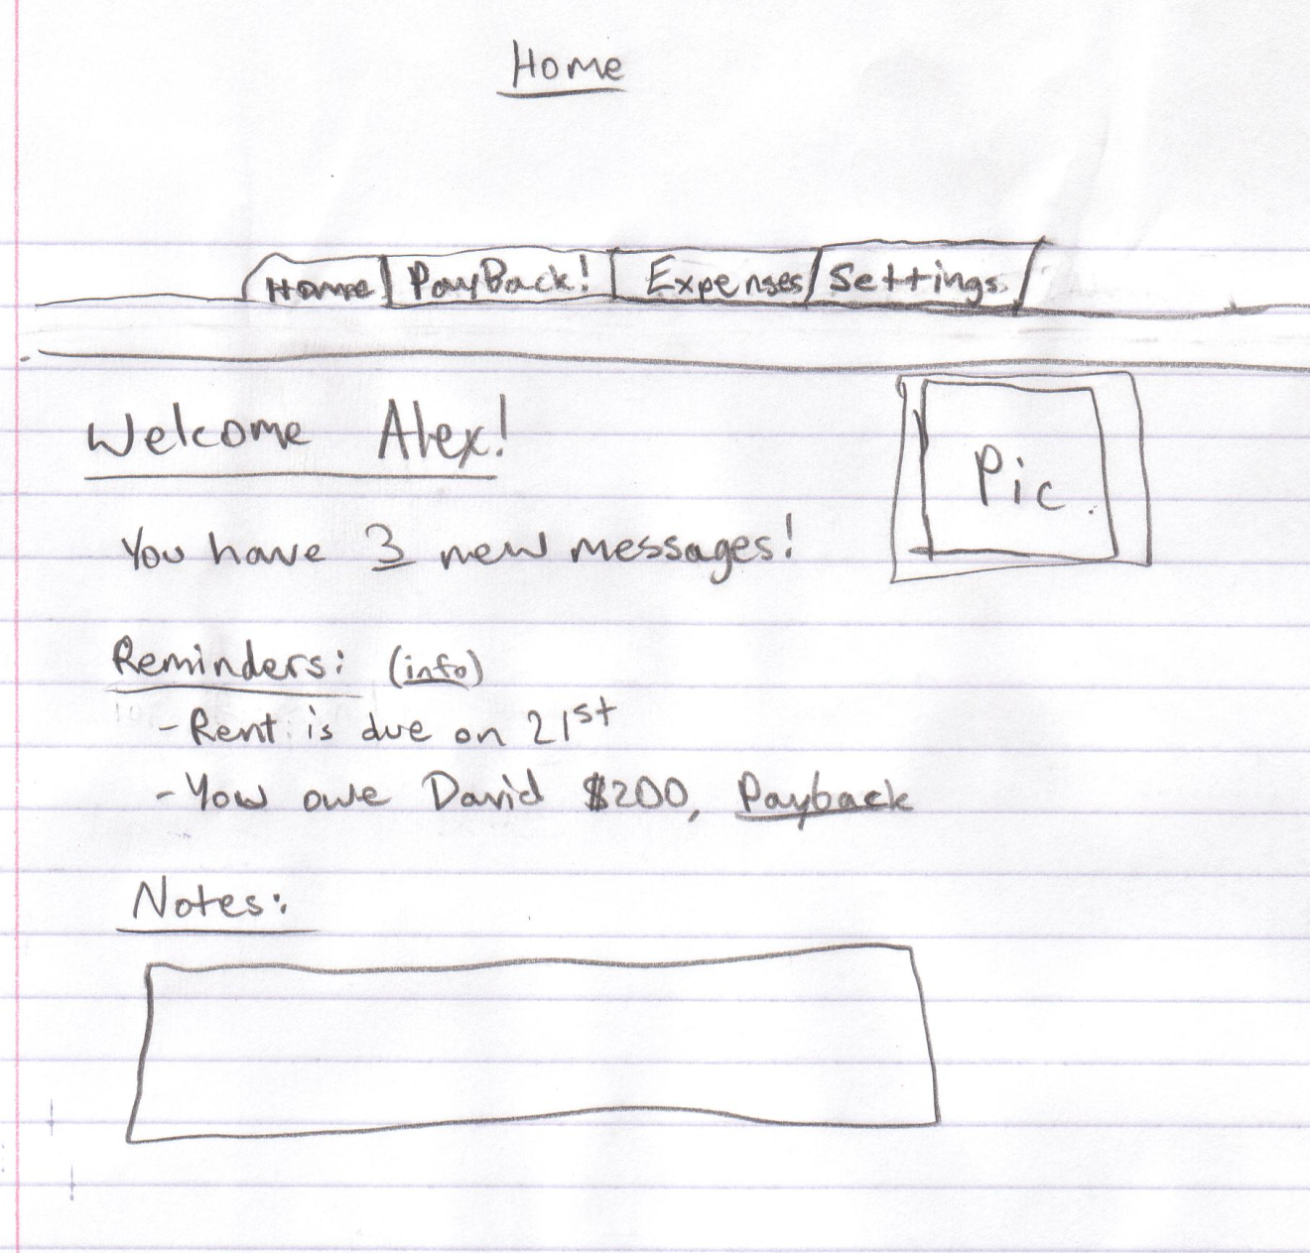

Expenses – Roommates Page
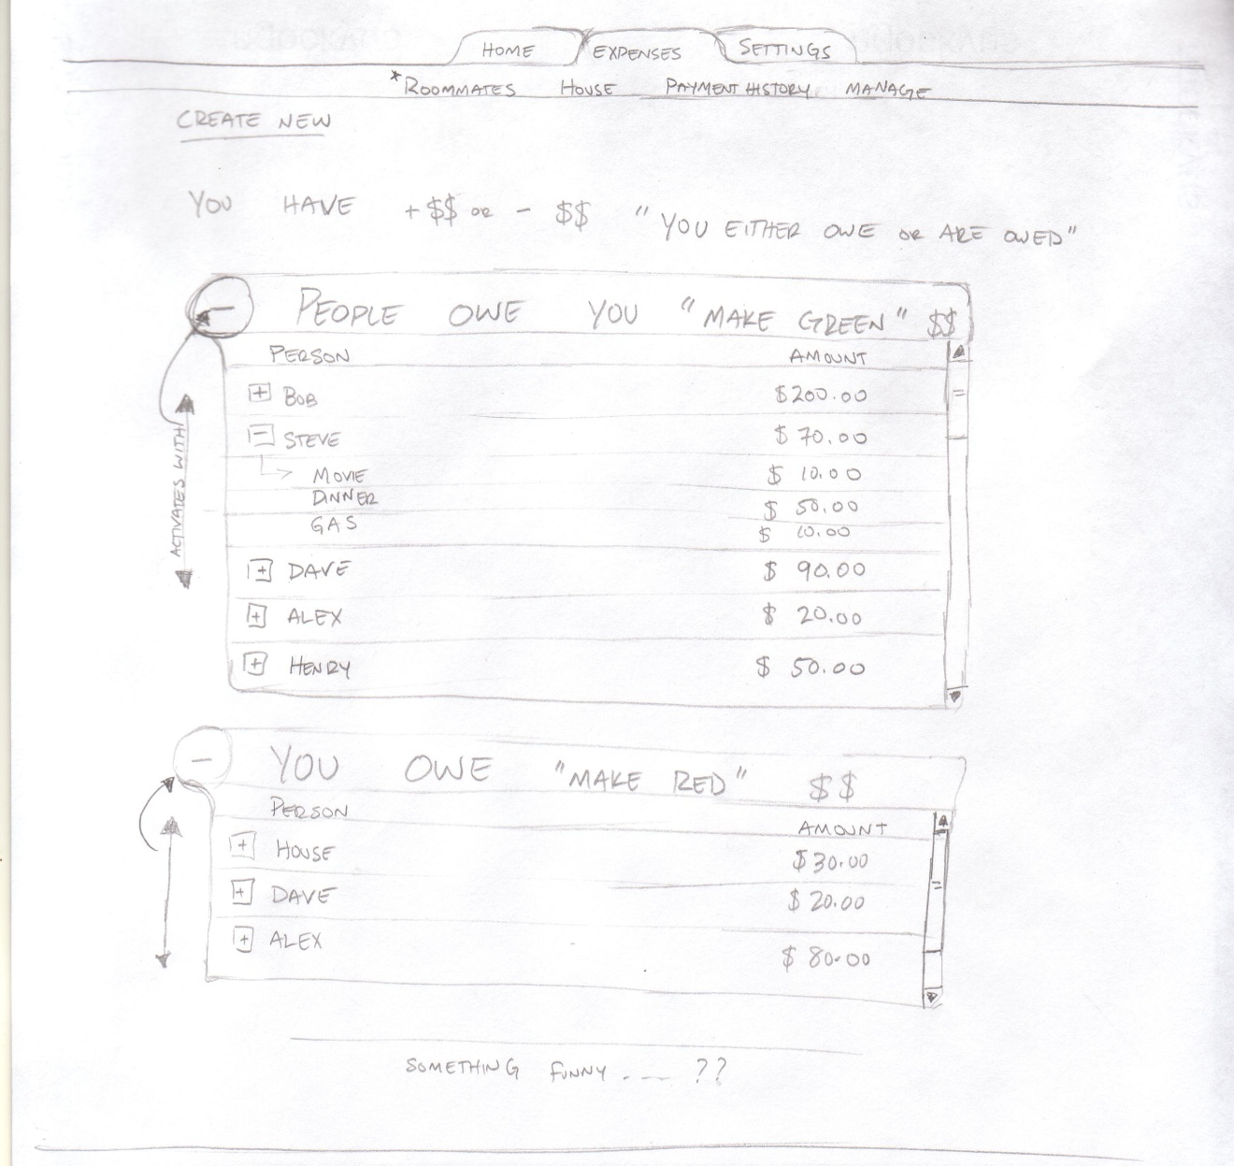

Expenses – Payment History Page
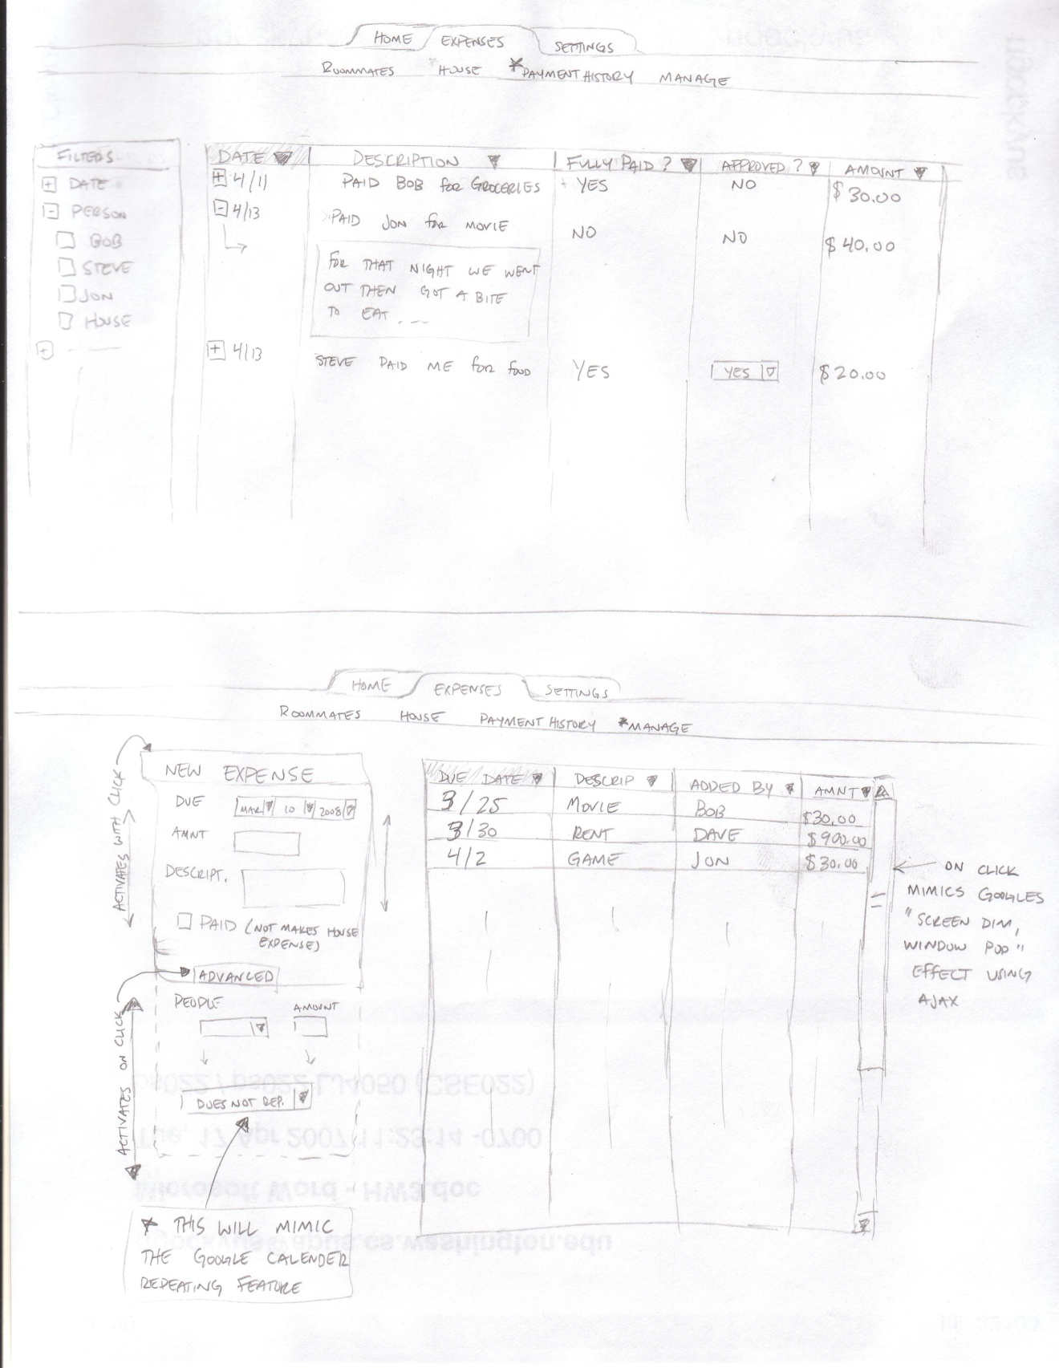

Expenses – Manage Page

