U-Mail

Alex Benson, Elliot Conant, Chris Hacking, Alex Meng, Michael Ratanapintha, Joseph Woo

System Design Specification and Planning Document

Draft 2
April 28, 2008

CSE 403 - CSRocks Inc.
Revisions
Version | Primary Author(s) | Description of Version | Date Completed
1 | Joseph Woo | Started Document | 4/24/08
1.1 | Alex Benson,  Michael Ratanapintha | Doc and test plan | 4/24/08
1.2 | Alex Benson  Joe Woo  Michael Ratanapintha | Added schedule  Added risks  Formatting clean-up | 4/27/08
1.21 | Alex Benson | Added MVC diagram | 4/27/08
1.3 | Alex Meng | Revised schedule | 4/27/08
1.4 | Michael Ratanapintha | Added UML class diagram  Rewrote architecture intro | 4/28/08
2 | Chris Hacking  Alex Benson | Added UML Sequence diagrams  Added database schema  Added design alternatives/assumptions | 4/28/08
System Architecture

Introduction
For our U-Mail application we will have three tiers: a database, a controller, and a user interface or view.

The database, implemented in Microsoft SQL Server, is responsible for storing users’ profiles. Each user’s profile will contain their login information, as well as all their mail from their various accounts. Their profile will also contain their address book which will be integrated from their various email accounts. Each profile will have its own tables in the database. This way, indexing and other operations (deleting, updating, etc…) will be relatively fast and will not cause conflicts if multiple users try to update simultaneously. Potentially sensitive data in the database will be encrypted using a key specific to each account.

Our controller will mainly send and receive mail from outside servers. We will communicate with these servers using third party libraries that understand and form a model wrapping around the POP3, SMTP and IMAP protocols. The controller also filters mail, using a rule-based filtering system (nature to be determined) and the SpamAssassin spam filtering library. The controller will also read and write data in the database using the ADO.NET classes for SQL Server (these and the database schema form another part of the model). While some of these data will be taken from incoming mail from outside servers, much of it will come from the UI instead. In particular, the controller will take mailbox listings and mail messages from the data tier and send them to the UI tear for the user to read. The controller will also receive configuration changes and drafts of messages being composed from the UI tier, and will store these to the database.

The UI or view is the point of interaction between the user and our system. Using the view, the user can view mailboxes, read mail messages, compose mail, and configure the U-Mail system. The view will constantly interact with the controller to store and display the user’s data, through the ASP.NET programs that create the various UI web pages and send them to the user mainly as HTML and JavaScript. The client-side JavaScript will allow much of the interaction between view and controller to happen asynchronously, without disrupting the user.

Pictorial overview (MVC)
The Model-View-Controller (MVC) diagram below shows the high-level view of the system outlined in section 1 more vividly.
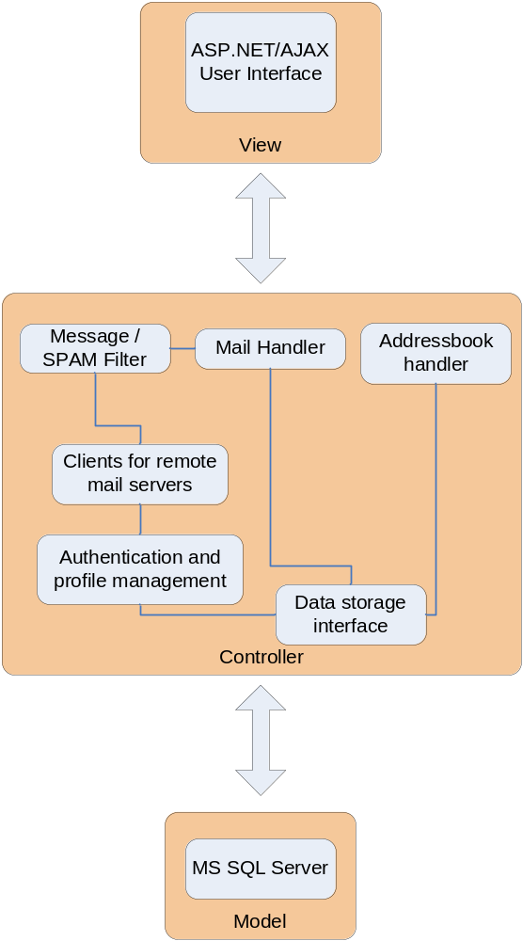

Design view - UML class diagram
This diagram represents the “functional” parts of the mail client, which represents most of the controller.
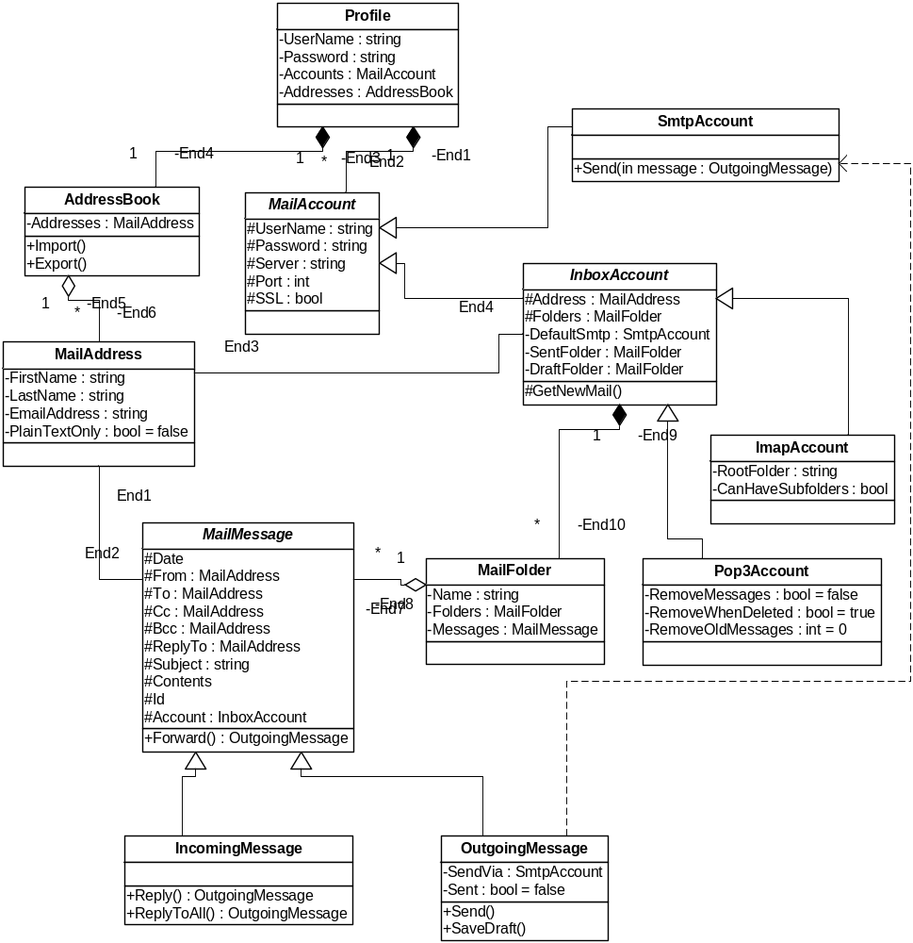

Process view – UML sequence diagrams
Message Composition
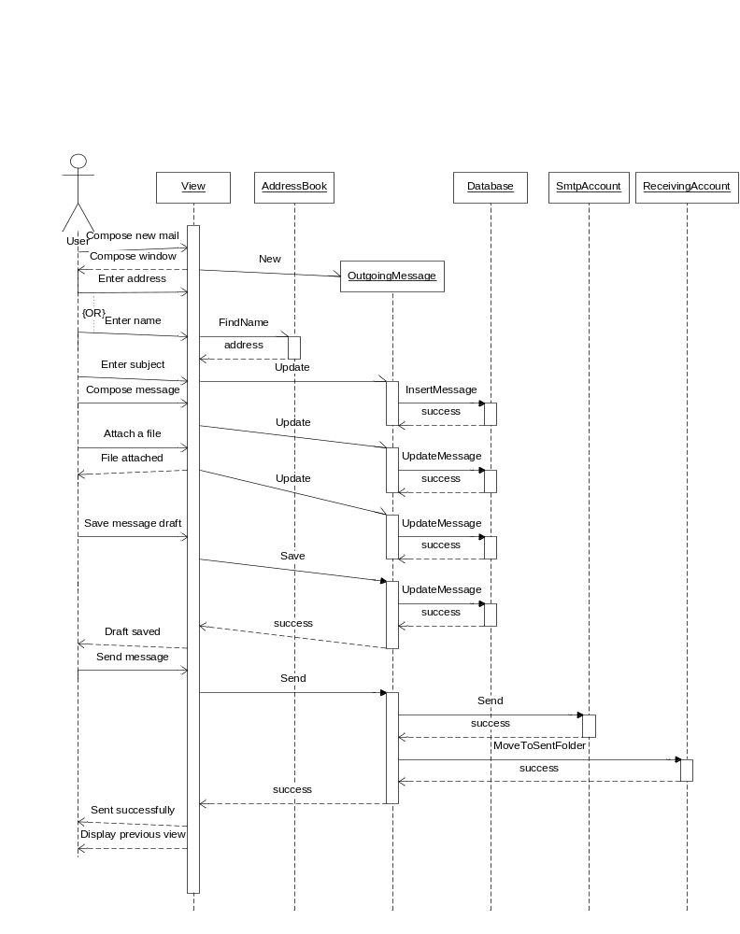
Account Creation
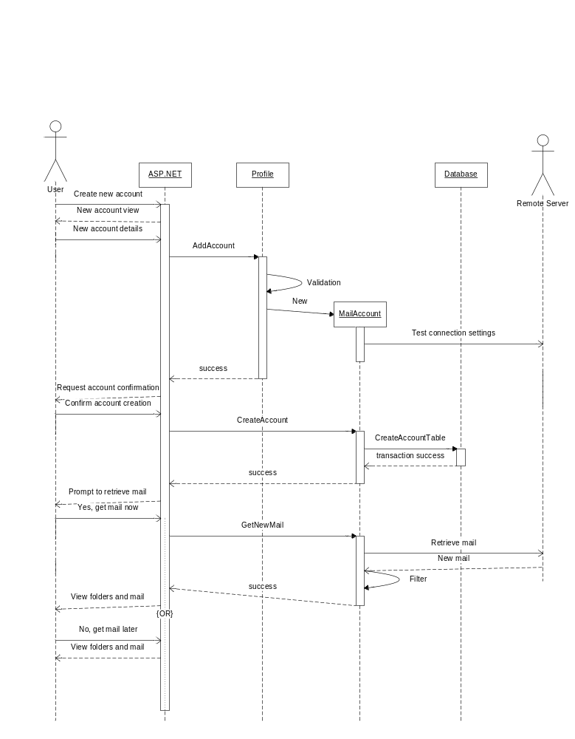

Database Schema
Static tables are a fixed part of the database schema and dynamic tables are generated programmatically according to the templates below. The creation of the unique tables for each profile will allow multiple users to modify data at the same time.

Static Tables
Profiles
- Name
- PassHash
- Other Profile Information
The profiles table has a one-to-many relationship with accounts, and each profile has its own addresses, folders, and messages tables.

Accounts
- Profile ID (foreign key)
- Account information (server, login, pass, etc.)
Each account is associated with a profile.

Dynamic Table Templates
Addresses (one table per profile)
- Name
- E-mail
- Other contact info
Folders (one table per profile)
- Account ID (foreign key)
- Name
- Folder meta-data
Messages (one table per account)
- Message Meta-data (to, from, cc, etc.) in separate fields
- Message contents
- Folder ID (foreign key)

Design Alternatives and/or Assumptions
- We chose to use ASP.NET and C# because they are familiar to many of the group members, and easily learned from Java (as opposed to learning a totally different language/toolkit).
- POP3, IMAP, and SMTP should cover the mail protocols our users need. HTML-accessed mail accounts, like Hotmail, are already accessible from anywhere, as is Exchange (via Outlook Web Access).
- We selected SpamAssassin, despite it being in Perl (while the rest of the project is C#) because we consider it one of the best and most complete tools of its kind, and there already exist C# wrappers for it.
- We assume the ability to do full-text search of all email is not considered a critical feature at release.
- We elected not to include a SMTP server in U-Mail itself since we assume anybody with a mail account will already have their own SMTP server.
- We chose to encrypt data in the U-Mail database because we believe that privacy in the case of snooping admins or compromised servers In the event that we can’t allow users to reset forgotten passwords when encryption is used, we will make encryption optional.
Development Plan

Team Structure & Responsibilities

Architect (Chris Hacking)
- Designing interfaces.
- Designing APIs.
- Designing and identifying components.
- Defining database schemas.
- Final design decisions on features and implementations.
- Ensure component integration.
- Adhering to the MVC paradigm: ensuring architecture represents MVC.
- Attend customer meetings

Project Manager (Joseph Woo)
- Schedule internal, customer, and technical meetings.
- Communication between customers and external groups.
- Submit final deliverables to upper management.
- Maintain point of contact role within the group.
- Attend customer meetings.
- Update wiki's, making meeting notes available for the group.
- Maintain project schedule.
- Transcriber during meeting.

Software Developer and Test
- Implements components and features based on design architecture.
- Responsible identifying, resolving, and verifying bugs/defects.
- Provide feedback to architect regarding coding/design concerns.
- Develop unit tests for each class built.
- Develop testing applications for project.
- Performing all unit tests and passing them before submitting code to source control.
- Maintaining documentation for code developed.
- Review code of peers.

Project Schedule

Task/Milestone | Estimated effort | Date due | Resource(s)
Set up bugzilla | 1 day | April 20 | Chris Hacking
Set up initial db | 1 day | April 25 | Chris Hacking
Create DB Schema | 1 day | April 26 | Chris Hacking, Elliot Conant
GUI talks to DB | 1 day | April 28 | Joe Woo
Set up Forms Authentication | 1 day | April 28 | Joe Woo and Chris Hacking
Commit base code (empty files?) to SVN | 1 day | April 28
Find .NET module for SpamAssassin | 1 day | April 28 | Chris Hacking
Design login screen | 1 day | April 28 | Joe Woo
Design mailbox view | 2 days | April 29 | Joe Woo
Design compose view | 2 days | April 29 | Joe Woo
Create initial script for nightly build/test | 1 day | April 29 | Michael Ratanapintha
Design account creation form | 1 day | April 30 | Joe Woo
ZFR Release |  | April 30 | Everybody
Implement account creation | 2 days | May 2 | Developers/Testers
Implement IMAP retrieval | 4 days | May 6 | Developers/Testers
Implement POP retrieval | 4 days | May 6 | Developers/Testers
Implement plain text composition | 2 days | May 5 | Developers/Testers
Implement SMTP message sending | 2 days | May 8 | Developers/Testers
Implement address book | 3 days | May 9 | Developers/Testers
Implement message filtering | 2 days | May 11 | Developers/Testers
Beta Release |  | May 12 | Everybody
Design account creation templates for popular mail services | 1 day | May 14 | Chris Hacking
Implement rich-text composition | 3 days | May 16 | Developers/Testers
Add support for attachments | 3 days | May 16 | Chris Hacking
Implement draft saves | 2 days | May 16 | Developers/Testers
Implement LDAP support | 3 days | May 16 | Developers/Testers
Implement contact import functionality | 3 days | May 23 | Developers/Testers
Implement message search | 2 days | May 23 | Developers/Testers
Implement support for multiple SMTP servers | 2 days | May 23 | Developers/Testers
Integrate SpamAssassin | 5 days | May 30 | Chris Hacking
Add support for multiple FROM addresses | 2 days | May 30 | Chris Hacking
Final Release |  | June 6 | Everybody

Risk Assessment

Risk | Chance of occurring (High, Med, Low) | Impact if it occurs (H,M,L) | Steps taking to increase chance it won’t occur | Mitigation plan should it occur
We are unable to deliver all of the promised features. | High | Medium | After we create the architecture, we’ll have a better picture how easy it is to implement all the features we want. It will gives us a better picture of what is feasible and what is not. | We will rank all of our features from most important (needs) to least important (wants). This way, have a systematic way of prioritizing what we should have in our shipped project. So when push comes to shove, we will be able to skim the unnecessary features.
Our customer realizes that the given requirements are incomplete or incorrect. | Medium | Medium | We will meet with our customers often so that we focus on developing only the features they want and keep their vision in mind. | If the requirements do change, we have to ensure that our architecture is flexible enough to change and meet the new requirements without requiring a significant amount of re-coding to be done.
Team members are not familiar with C# or the .NET Framework. | High | Low | All of the team members have had extensive experience with Java and C# is almost syntactically identical. However, learning the .NET library might take significantly more time. So right now, since we don’t have anything to code, anyone not currently working on the SDS is familiarizing themselves with .NET. | If we run into significant roadblocks when it comes to implementation time. There are a wealth of tutorials on the web (asp.net, fourguysfromrolla.com, etc…). Also, there are at least two members of the team that are very familiar with C#/.NET and can fill the gap in the meantime while the other members are learning C#/.NET.

Third-party libraries are insufficient or unreliable. | Medium | Low | On our wiki page we are compiling a bunch of different libraries that perform essentially the same task. That way, if the library we decide to go forth with doesn’t have the features we want or is buggy, we have an alternative easily at hand. | We will make our code as general as possible so if any changes to our third party libraries do occur, we can easily swap over to another library without much difficulty.
Our database cannot scale to store all of our users’ emails. | Low | High | Chris Hacking has come up with an innovative architecture that will generate a table unique to each of our users. This will allow for easy indexing and reduce lag by separating each user’s email from each other. | If Chris’ solution does not work like we planned, we can always limit the amount of e-mail users can store on our database. This constraint will reduce the amount of load placed on our database.
Team members have difficulty staying on task | High | Medium | Have written agenda for each meeting and goal completion times | Allot extra time for work items. Getting done early is bonus.
Test and Documentation Plan

Test Plan
- Unit test strategy
  - Tests classes and methods to ensure operation of the smallest system components
  - Tests will be developed by those responsible for individual modules/classes
  - Specify minimums for each method (ex: At least 5 sets of data for each, target border cases)
  - Daily, with nightly builds
- System test strategy
  - Tests interaction between classes and methods to ensure interoperation of system components
  - The architect will have close overview and/or direct involvement in test creation
- Usability test strategy
  - Tests the transparency of system functions when presented to an end user
  - PM will supervise their development as he is point of contact with customers/users
  - Developed around use cases, provide user with a goal, observe usage, deviance from use case
  - Weekly usability tests
- Quality Strategy
  - Bugzilla: our Bug tracking solution
    - Assignment will initially go to the involved class/module’s owner
    - After a time of inactivity (2-3 days?) others will have to take responsibility

Documentation Plan

An online help system with context-sensitive help will be the main access method for the user’s guide. In cooperation with the user interface designer (to be determined), the Architect will write a high-level outline of the user’s guide as part of his work designing the high-level system architecture. The Architect will also outline an administrator’s guide, a must to provide for proper setup and operation. However, both the user’s and administrator’s guides will be written in full by all the developers, with each developer responsible for those parts of the guides touching his subsystem. The Architect will read and revise the guides to make sure they agree with his vision; however, editing for style will, if needed at all, be left to the Project Manager’s designee.

