Visual Registration 1

Zachary Allred
James Hu
Alyssa Irwin
Chad Mackley
Allan Quiaoit
Jacob Newgard

Software Requirements
Specification

Draft 1.0
April 18, 2008

CSE 403 - CSRocks Inc.
Revisions
Version | Primary Author(s) | Description of Version | Date Completed
1.0 | VR1 Team | Initial write up. | 4/18/08

Overall Description

Description

We are going to produce a piece of software that makes registering for classes at the UW quick and easy. Foremost, our software is going to simplify the process of registering for classes; it'll display a visual schedule that updates dynamically as you add or remove classes (or even entire schedules), while making searching and locating classes you want (or need) to take very easy. We’re going to allow users to add individual classes, or even whole schedules found with our schedule finder feature. Students will also be able to save and load schedules they’ve found, so if they can’t make up their mind between two or more schedules, they can save those schedules and come back to them later. Unlike the UW, we’re going to allow students to add classes that conflict or are full to their visual schedule so they can see what their schedule would look like, even if they can’t officially register for it at that time.
Our GUI is going to consist of a large pane with a visual schedule on it, similar to the visual schedule the UW uses now, or to a Google Calendar, and one or two smaller panes to the right that control searching and browsing for classes, let the user choose different options, and display search results. Once the user finds a class, or classes, they want to add to their visual schedule, they can click on it/them to update their visual schedule in the main pane. Once they’re satisfied with their visual schedule, they can click a “Register” button and our software will attempt to register that schedule for that student with the UW.
Our main goal with this project are to make the registration process as quick and easy as possible by consolidating all the tools the UW already provides (like search and browse), as well as some handy new features of our own, into one slick GUI that is easy to navigate and straightforward to use. Our product may come with a short help/tutorial section to help new users, and to answer common questions about the software.

Scope

Our software will allow students to register for classes at the University of Washington, as well as saving and loading schedules. It will not allow students to register for classes anywhere besides UW Seattle, nor will it allow students to register for schedules that have classes with conflicting times. The software will not generate a schedule on it’s own for the student, but it will take user input and return lists of potential schedules, or suggest classes. The registration software will run on a web server, and be very dependent on the UW course database.

Use Cases

Use Case Summary Diagram

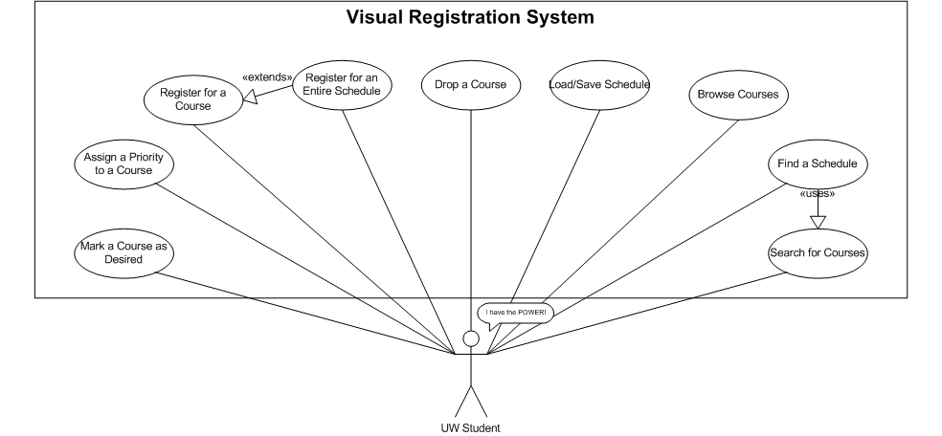

Use Cases

Goal | Add a course to schedule
Level | User
Primary Actor | Student
Precondition | User is a current UW student and is logged in to their myUW page during their registration period.
Success end condition | Student adds a class to their visual registration calendar.
Failure end condition | Student does not add a class to their visual registration calendar.
Trigger | Student pushes the “Add Class” button.
Main Success Scenario | - Student searches for a class by course name.  - The search engine finds and displays available courses that match.  - Student mouses over different sections to see how they look in their schedule.  - More detailed information is displayed for any currently moused over course.  - Student selects a section and clicks the “Add Class” button.  - Class is added to their Visual Registration Schedule.
Extensions | 2a. Course does not exist.  2a1. Student is prompted to search again  2b. Course is not offered that quarter.  2b1. Student is prompted to search again  5a. Student does not want any of the available sections.  5a1. The student tries a new search, logs off, dances, whatever.  5b. Available sections do not fit into the students current Visual Registration Schedule.  5b1. Student adds class to wish list.  5b2. Student adds classes from current schedule back to wish list.  5b3. Student runs schedule finder on wish list.
Variations | - Student searches for class by department, graduation requirement, or from general credit search.  4. Student adds the class to wish list.

Goal | Find a schedule built from courses in the wishlist
Level | User
Primary Actor | Student
Precondition | User is a current UW student and is logged in to their MyUW page during their registration period.
Success end condition | Student finds a schedule
Failure end condition | Student does not find a schedule
Trigger | Student pushes the “Find a Schedule” button
Main Success Scenario | - Student searches for a class by course name.  - The schedule finder displays available courses matching the search criteria.  - Student adds course to wish list  - Student repeats steps 1-3 until wish list is complete.  - Student selects “Find a Schedule” button.  - Schedule Finder finds a schedule with the classes from the wish list.
Extensions | 2a. Course does not exist.  2a1. Student is prompted to search again  2b. Course is not offered that quarter.  2b1. Student is prompted to search again  3a. The course is already on the wishlist.  3a1. The schedule finder notifies the student and waits for further input.  6a. No schedule exists with courses from the wish list  6a1. Schedule Finder tells the user no schedule exists.  6a2. Schedule Finder gives the user schedules with the most classes from the wish list as possible.  6b. Wish list contains more classes than the student is allowed to take in a quarter.  6b1. Schedule Finder gives the student various schedules with the selected courses that does not exceed the credit limit.
Variations | 1a. The student searches for (a) specific section(s) of a course.  1a1. The scheduler will only display the section(s) that match the criteria.

Feature List
Feature | Target
View a schedule | Beta
Add a class to a schedule | Beta
Remove a class from a schedule | Beta
Search by Course name | Beta
Clear your schedule completely | Beta
Register your schedule with UW | Beta
Add an entire schedule | Final
Save your schedule(s) | Final
Save your schedule(s) | Final
Load your schedule(s) | Final
View campus map | Final
Color coded visual schedule and search results | Final
Search by Department | Final
Search by Time slot | Final
Track what courses a student has taken | Stretch
Rate schedules based on how helpful they are to the student | Stretch

UI Prototype

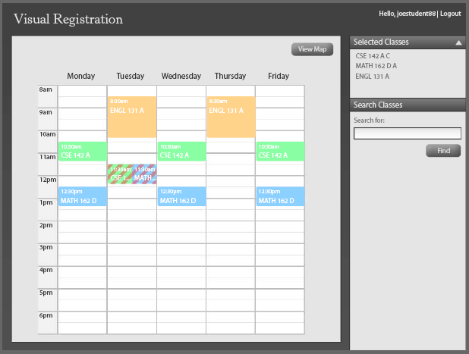
Figure 1. Course schedule with a scheduling conflict.

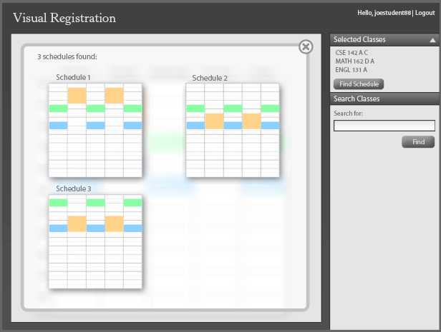
Figure 2. Resulting schedules found from the [Find Schedule] button.

