Getting started with Qt

- Download Qt (LGPL license) from http://qt-project.org/downloads. If you have other compiler installed already, you should download the one that matches your system. If not, you need to download compiler to make Qt creator comspile your code
- Install Qt.

Using Qt’s editor and compiler:
- Run “Qt Creator”
  - By double clicking the .pro file.
  - Or select “Open file or project” from File menu. Select the file “ImgFilter.pro”
  - Click “Configure Project.”
  - Click on the “Sources” folder. You should see a file called Project1.cpp. This is the only file you should need to edit.
  - To compile click on the green play button at the bottom left of window.
  - You can select between debug and release builds above the green play button.

Using Visual Studio’s editor and compiler:
- Run “Visual Studio” (2010 preferable)
  - Select “Open Project/Solution” from File menu.
  - Select the file “ImgFilter.vcproj”
  - Right click on the ImgFilter project and select “Properties”
  - Select “Configuration Properties -> C/C++ -> General
  - Update the directories under “Additional Include Directories” with “Qt” in the name according to where you installed Qt.
  - In the same window select “Configuration Properties -> Linker”.
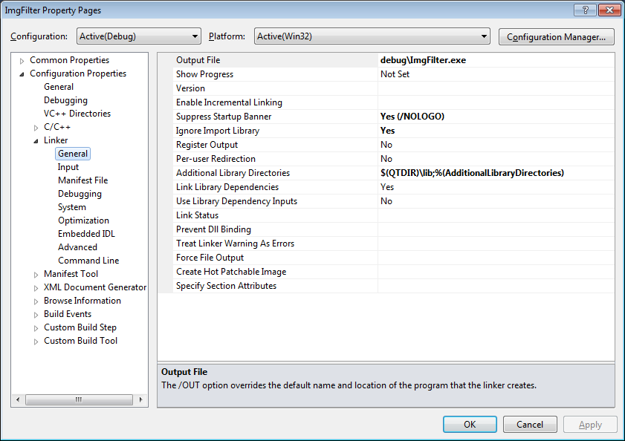
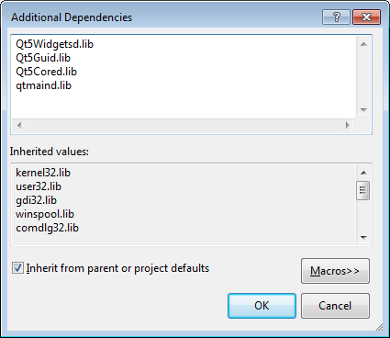
  - Update the directory in “Additional Library Directories” according to where you installed Qt and add the libraries.
  - Compile.
  - Run.
  - If it complains about not finding Qt’s dlls when running, you should update your system’s “path” variable to include Qt’s “bin” directory. To update the “path” variable, type “environment” into the window search box and select “Edit the system’s environment variables”. Press the “Environment Variable…” button and find “path” in the second list box.
  - Qt also has a VS add-in that is nice for editing UIs. This isn’t necessary for the assignment, but you can find it at the same download page. Visual Studio Add-in 1.2.2 for Qt5 is preferable.
  - You shouldn’t have to do this – but just in case. If you’d like to convert a Qt project to a Visual Studio project use the following command “qmake -tp vc test.pro”. This will create a file test.vcproj.
  - If it complains about MOC/UIC not found, make sure the Qt Project Settings look like this:

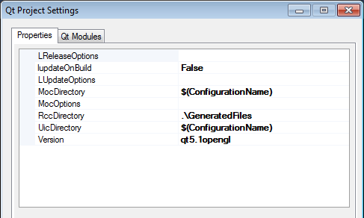
  - And the modules should selected like this:
