Lab #2a
Creating Images for Use in the Sandbox
Images can be used as cutouts in place of characters and props in the Cinematic Sandbox. You can find images online but make sure they are in PNG format or else you will likely see the background. If there is an image you really want to use that is not a PNG, you can cut the image out using Photoshop.
Save the image and open it in Photoshop.
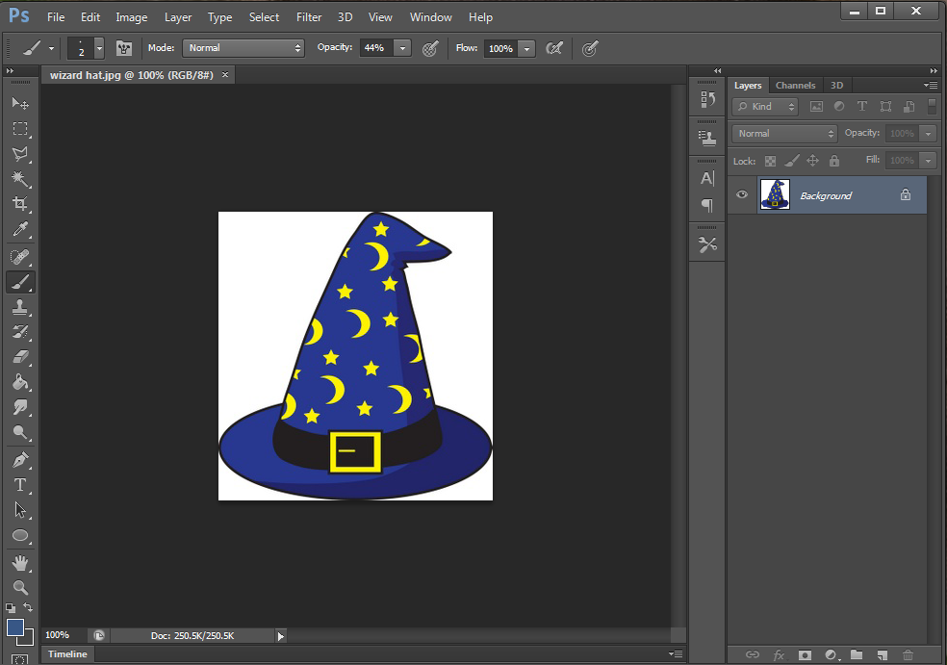
The first step is to convert the locked Background layer on the right into a normal Photoshop layer. Go ahead and double click Background.
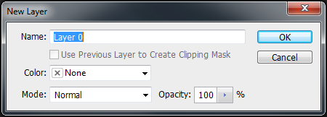
A dialog box like this should pop up. Just click OK. It is now a Photoshop layer and can have parts of it deleted to become transparent.
The quickest way to get rid of the background is by using the “magic wand” tool, which is used to select areas of continuous color.
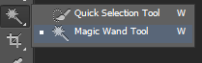
Click the background sections around the object. In this example you would select the white pixels surrounding the hat. Then just hit ‘Delete’ and the old background should be gone, replaced by a checker pattern. Anything that is checker patterned is transparent and will not show up once brought into the sandbox later.
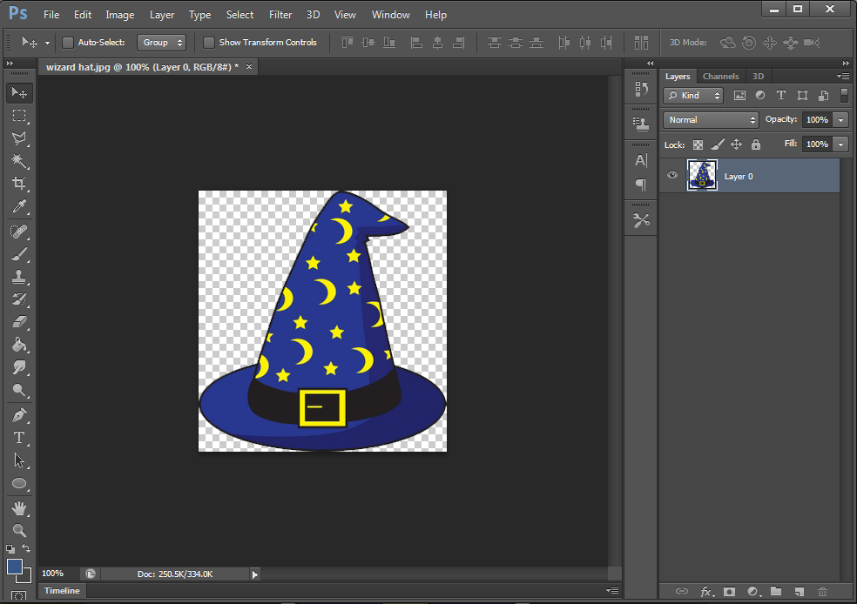
If the magic wand missed some areas, you can remove the parts it missed using the eraser.
Before activating the eraser, be sure to click on the dark space around the image using the magic wand to deselect everything (otherwise you might have issues getting the eraser to work).
Save the picture as a PNG.
Adding Images to the Sandbox
Some props can have images applied to them. If an object has this capability and if you have images in your images folder (explained below), an "+ Add Image +’ option will be available in the right panel.
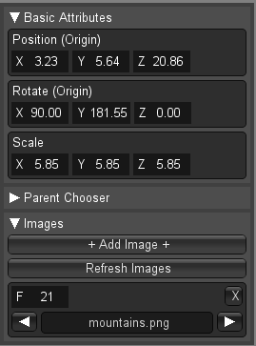
Inside your cinematic sandbox project folder there should be a folder called "images." Put any images you want to use in the sandbox here.
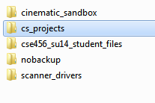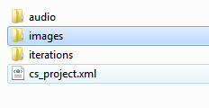
When you click "+ Add Image +" you will be able to flip through them. You can key images by moving to a new spot on your timeline clicking "+ Add Image +" again and selecting a new image, a new key will be added to your timeline. If you add an image to your image folder while your project is open, it will not appear as an option until you click Refresh Images.
Adding images to planes and the Wall object is a good cheap way to add in backgrounds and even simple custom characters. If you use PNG files the transparent pixels will show up as such in the 3D view as well.
For example, if you want to have your floor to have a texture, you first create a plane and place it on the floor. Resize and rotate as needed to make the shot clear.
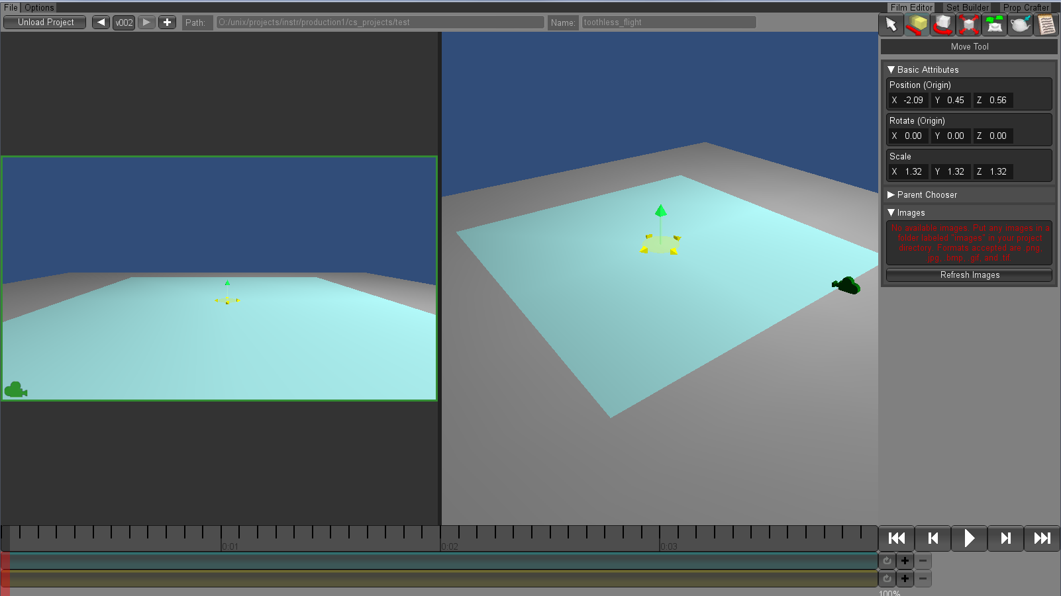
Hit ‘Q’ and you should see the option to apply images amongst your tools on the left menu column. Make sure you have the ‘images’ folder in the correct place and hit ‘refresh’ to see your images.
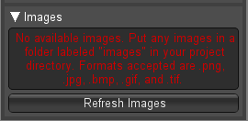
With the plane selected, click ‘+Add Image+’ to apply an image to the plane. You can cycle through your images if you have more than one with the triangle buttons.
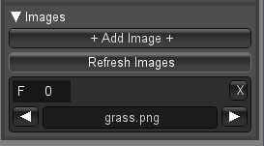
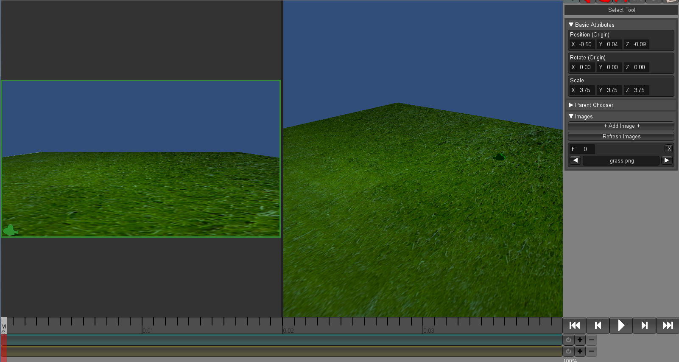
Note: For things such as a background or a floor texture, it is best to create these in the set builder and bring them into the film editor as opposed to making them in the film editor as if they are a character. This way, you won’t accidentally move the background or floor while moving around characters.
Using the same method we can add a background.
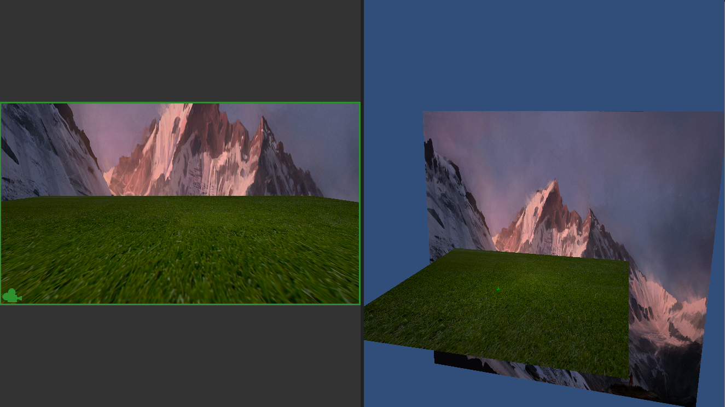
Now let’s add some custom characters. Instead of using a plane like we did before, custom characters are placed using pedestals.
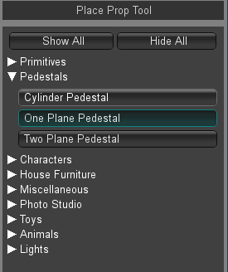
There are two types of pedestals that are used most often: one-plane and two-plane pedestals.
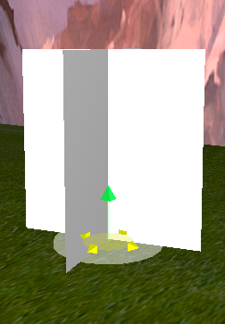
Two-plane pedestals are generally used for props such as trees.
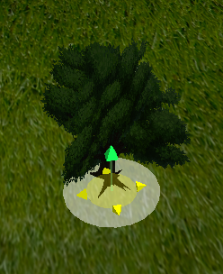
Custom characters use one-plane pedestals. Just like with the 3D models, these pedestals can have waypoints to simulate movement. Pedestals can also switch between images to create the illusion of movement. In this example, the character switches between flying and sitting to simulate a landing from flight.
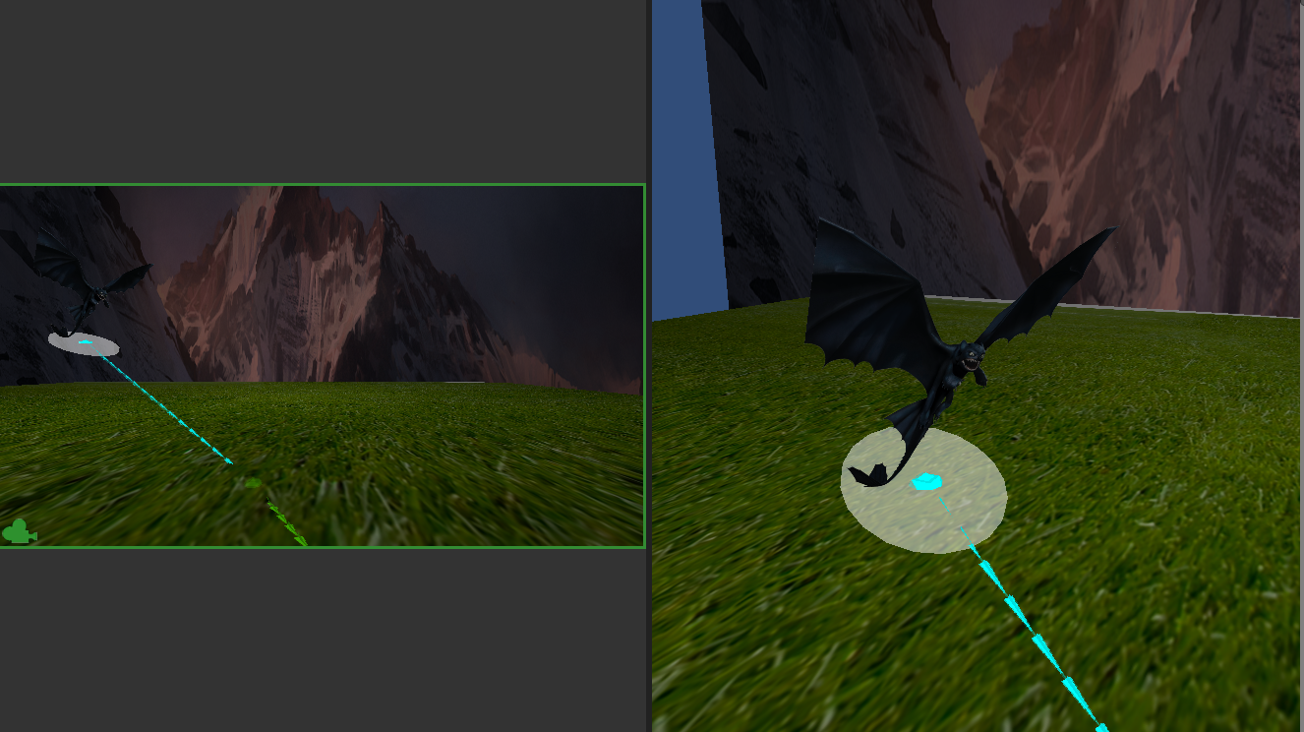
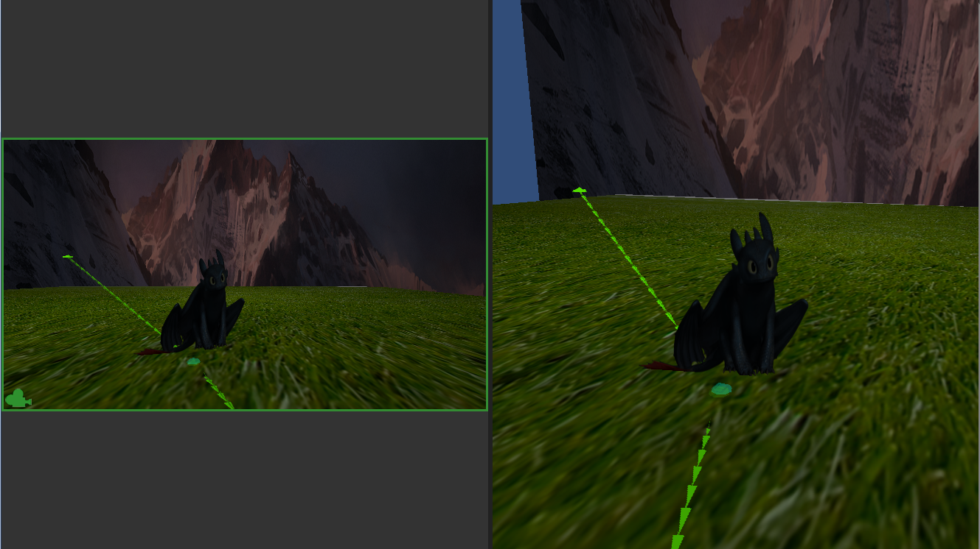
In order to switch between images, click on ‘+Add Image+’ and specify which frames you want the image to be on. You can also keep track of this using the time slider.
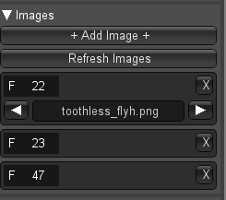
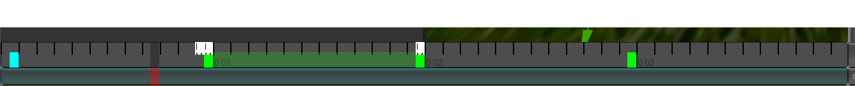
The white box corresponds to an image. Make sure the images don’t overlap one another or you will lose the transition between images. It’s best to have one frame between images when switching. Just like poses, you can move all the images on the timeline by holding shift and dragging the images along the timeline.

Parenting
It is possible to attach one object to another in the sandbox via parenting. Take a prop (for example, a wizard hat), and under the Parent Chooser in the Attribute Editor select one of the other objects in the scene (for example, Toothless). In this case, the wizard hat is now attached to Toothless.
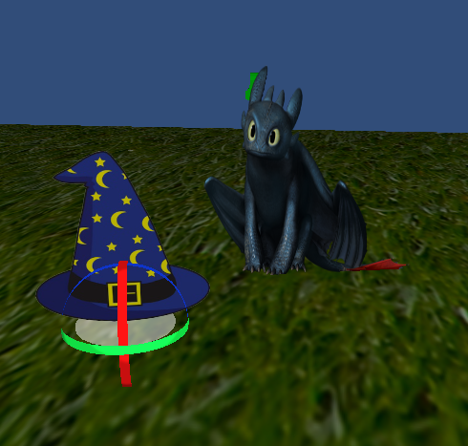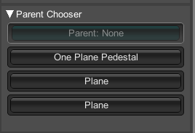
a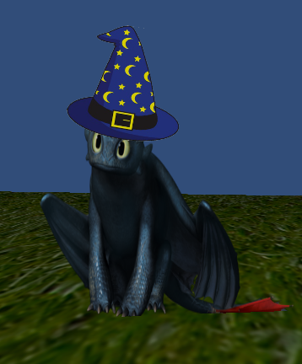
When first choosing the parent you'll see that the object jumps to a completely different location in the scene. Because of this, it is good practice to select a prop's parent before positioning it, rather than carefully placing it next to its future parent only to have that placement thwarted upon specifying its parent.
Nested parenting is supported; however, for simplicity try to keep it only one level deep.
What to Turn In
Create a short film similar to the one shown in the tutorial. Make sure to include:
- A set using planes and images
- At least one cut-out character using the pedestal with two different poses. These two poses should be related to one another (like in the Toothless tutorial). You can either find PNGs or JPEGs online but you will have to cut out JPEGs. You can also draw your own but you will have to cut those out too.
- One prop that uses the double pedestal (trees are highly recommended)
- Optional: Parent a prop to a character.

