Lab Exercise: Editing

Using Premiere
1: Open Premiere
Go to Start → All Programs → Adobe Premiere Pro CS6.
Or look under: C:\ProgramData\Microsoft\Windows\Start Menu\Programs\Adobe Production Premium CS6
Click "New Project".
2: Setting
Now, go to "Location" at the bottom, click "Browse..." and navigate to your folder on the network. If you haven’t made a folder yet be sure to create one:
O:\unix\projects\instr\production1\cse456_su15_student_files\[your student files folder].
Name your project cslab_audio_[lastname]_[firstname]. Hit “OK”. Next, click the "Setting” tab and change the following settings under General:
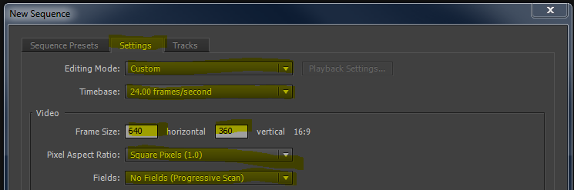
- Editing Mode - "Custom" (This will free up the resolution to be changed)
- Timebase - "24.00 frames/second"
- Frame size - "640" in horizontal, "360" in vertical
- Pixel Aspect Ratio - "Square Pixels (1.0)"
- Fields - "No Fields (Progressive Scan)"
- Sequence Name - “cslab_audio_[firstname]_[lastname]” (This can be changed later)
Once you’ve changed the settings above, click “OK”.

3: Import files into Premiere
The main interface should now have shown up.
The bottom half of the screen contains the Project Control Panel on the left and the Timeline on the right.
The Project Control Panel will show you the contents of your project, including imported media and sequences. The Timeline is where all of your editing will be done. It always shows the currently active sequence, in this case it will be the cslab_audio_[lastname]_[firstname] sequence. *Note that “sequence” in this case just means an edit of a film – a single Premiere project can contain multiple sequences.
The top half of the screen contains the viewports. The left viewport shows you individual media clips, and the right viewport shows you the Timeline, which is how your movie will appear in the end.
To get your files into Premiere go to File → Import... and again navigate to your folder on the network where you have saved boards.
Select the desired files (use Ctrl to select multiple files) and hit "Open." They should appear in the Project Control Panel. Alternatively you can drag and drop the files into the Project Control Panel.
Import all files you need, including audio clips.
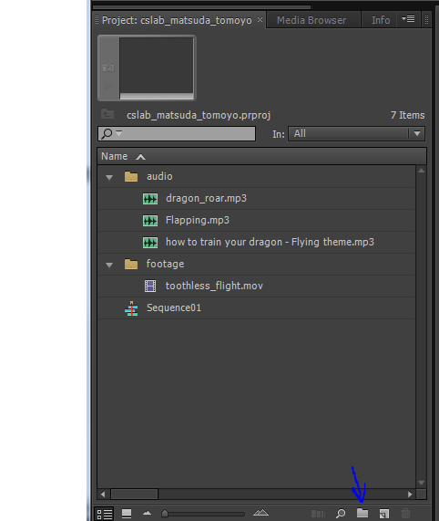
For your own sanity, you will want to create “bins” (basically folders) to organize the media in your project. Just click the folder icon to make a new bin, then drag your files into it.
4: Putting together the boards
Select the first shot you want in your movie in the Project Control Panel. Then left-click-drag it into the Timeline. You should see the clip appear as a rectangle at the start of the timeline.
If you hover the mouse over the right edge of the clip your cursor will turn into a red bracket with two arrows. This tool will let you adjust the length of your clip. All photo clips are going to be longer than you want, so you’ll be doing a lot of editing.
Repeat this process with all of your clips, dragging them after the previous one in the timeline. You will notice that Premiere has a nice feature that automatically tries to snap your next clip onto the end of the previous one. If you find that that your clips aren’t snapping to nearby clips hit the s key to toggle snap back on.
Now that you have them all in the timeline, scrub through your film and make sure everything appears the way you want them to in the top right panel. To scrub, click and move the yellow marker in the timeline or alternatively hit the play button under the viewport to watch it play in real time. You can also just hit the spacebar to play and pause.
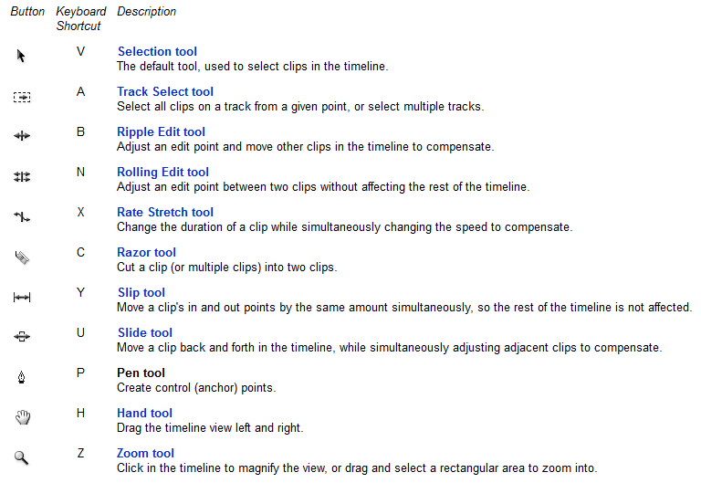
Tools to edit media tracks:

8: Export the Sequences
The last step is to export your film. Select your sequence in the Project Control Panel and export it. Now go to File -> Export -> Media...
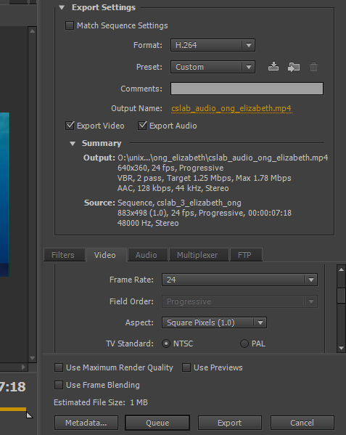
The file name should automatically be that of the sequence you are exporting.
Click cslab_audio_[lastname]_[firstname] and navigate to the place you want to export, which is your student folder.
Select "H.264" as the format. Go to the video tab, scroll down and find Basic Video Settings. Then change the Width and Height into 640*360. Make sure that Frame rate is “24” and Field order is “Progressive”.
When you’re ready, hit "Export". Don’t forget to save your premiere project.
In the future be sure to save your Premiere file frequently as you go and save iterations. This may not seem as relevant for this lab because it should be pretty quick, but it will become very important the more time you put into your editing later.
TODAYS FILES are found under: \\ntdfs\cs\unix\projects\instr\production1\cse456_su16_student_files\07_11_files
Use them to make your own version of today’s lab.

TURN IN: An export of today’s lab into \\ntdfs\cs\unix\projects\instr\production1\cse456_su16_student_files\07_11_turnin under a folder with your name.

