Animating in Photoshop

First, some Photoshop basics:

- To create a new document: Select File > New
- Change size to 1280 px by 720 px (This is a 16:9 aspect ratio, which is what we want to use)
- Hit OK to create your new canvas
- To open up an image (like your scanned thumbnails) File > Open > Find and select where your image is located
- Hit OPEN to create a new file with your selected image

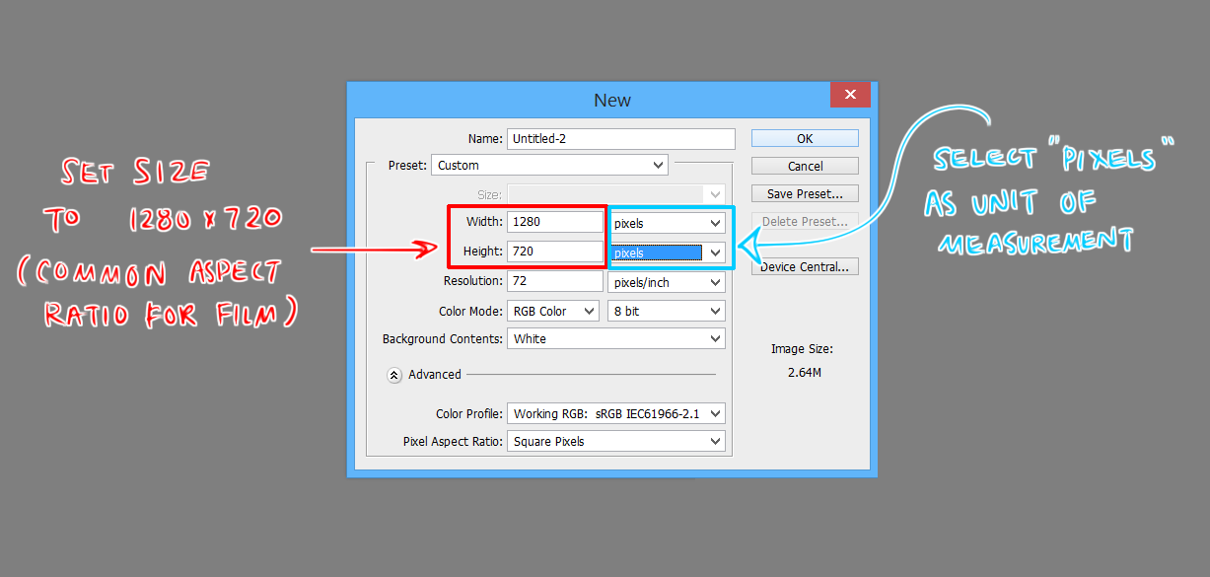

Other aspect ratios:
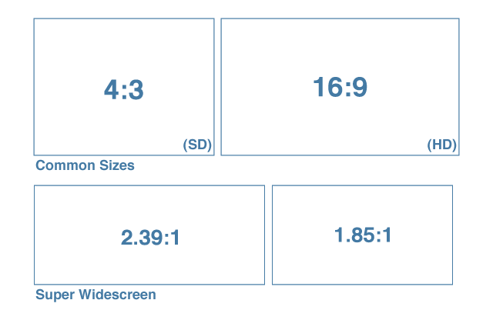

- There are a lot of tools and functions that Photoshop has but I want to highlight the tools you’ll be using most
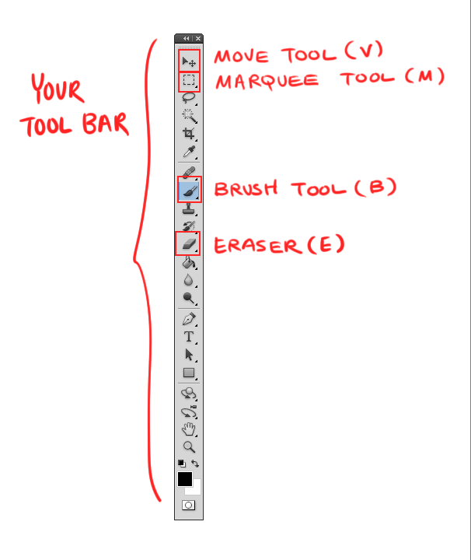

- There are also many components to the Layers Window, I’ve made a note of the options you should be most familiar with for this tutorial

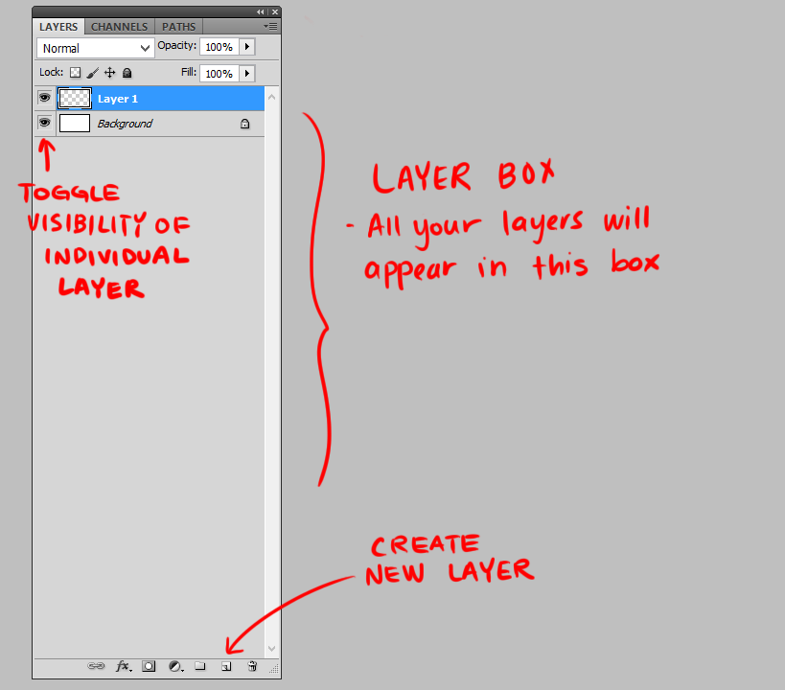

So let’s get started!
- First you want to have all your boards converted into individual layers
- You’ll be scanning your images (if drawn traditionally) and then copying them over to one single photoshop file
- If you’ve drawn your boards digitally, make sure what you want to animate has been compiled into one file as well
- For example, use the marquee tool (M) in order to select the area of the image you want to copy over
- A selected image will have a moving dashed line
- After you’ve selected what you want, copy (ctrl+C) and paste (ctrl+V) the image into your new document
- Repeat this until you have all the boards that you want over into the new file

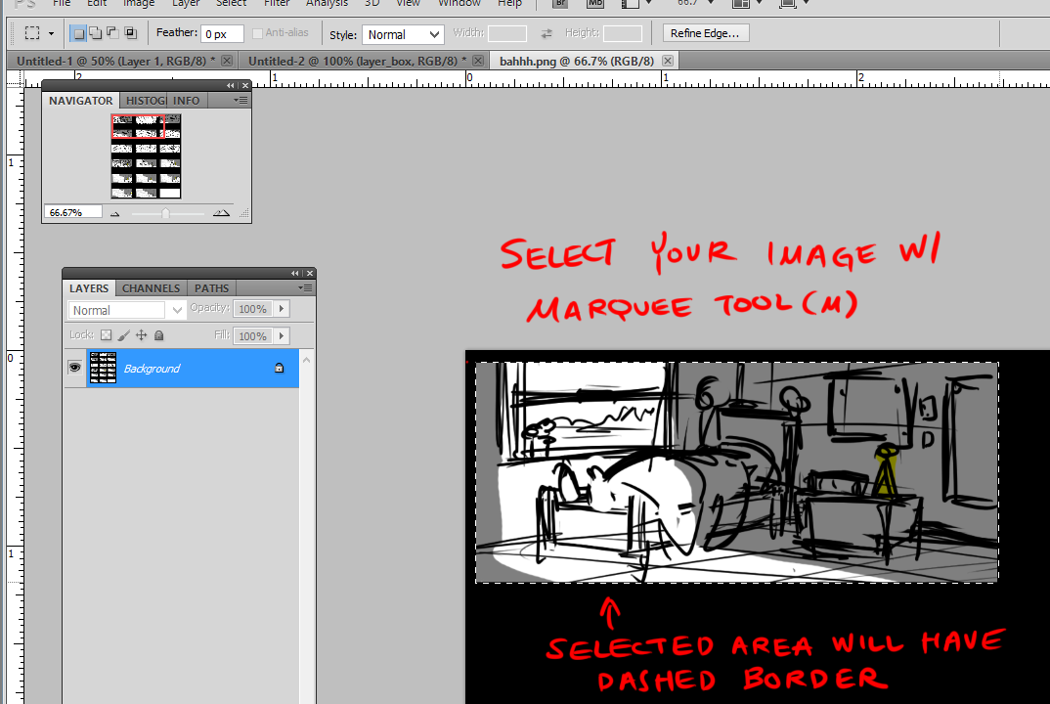

- Next, you simply want to toggle visibility of all your layers by simply clicking on the eye icon so it disappears

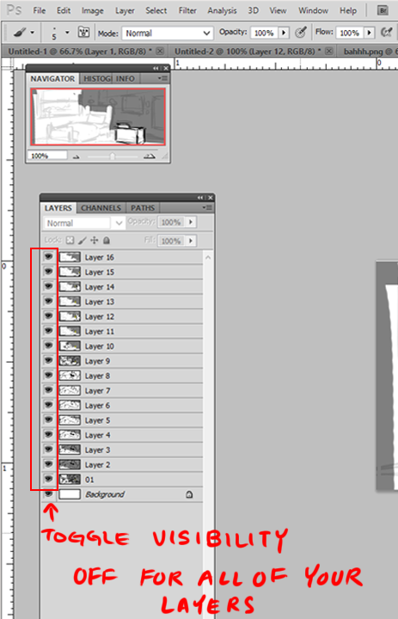

- To enable the Animation Window select Window > Animation
- A new tool bar will appear on the bottom of your screen
- There are two methods of animating in Photoshop – By using a Timeline or Frame by Frame
- We’re going to be animating frame by frame
- If not already in this mode, you can toggle it by selected the button with three white squares on the bottom right hand corner of the animation window

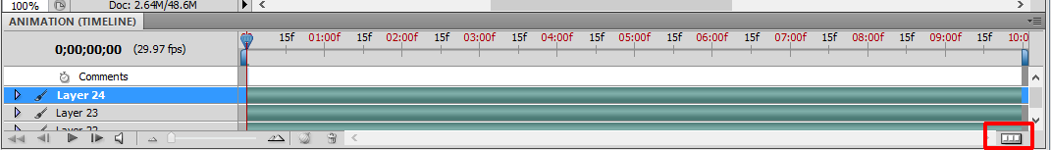

- It should look like this :

- Now we’re ready to add in our frames
- First: Toggle on the visibility of your board #1 in the Layers Window
- You should see the image pop up on the first frame in the Animation Bar
- Next: Create a new Frame
- Toggle OFF the visibility of the board #1 and toggle ON board #2
- Create a new Frame
- Toggle OFF the visibility of board #2 and toggle ON board #3
- Create a new Frame
- … and repeat the cycle until all your boards have been converted into frames

ALTERNATIVELY: You can do this quicker by toggling a drop down menu on the upper right hand corner of thee animation window and selecting MAKE FRAMES FROM LAYERS

- This will convert all your layers (including the background layer) into a new frame
- Make sure you scrub through to see if everything is in the correct order
- If not, simply select the misplaced frame and drag it to is correct position

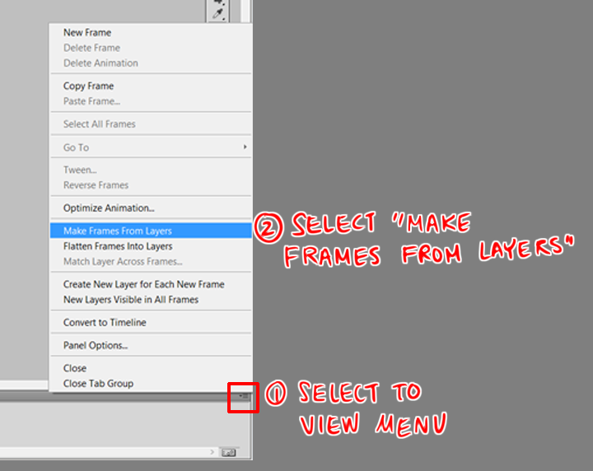

- Now we’re ready to add timing to our boards
- You can assign specific timing to each individual frame
- It’s a lot of trial and error
- You keep adjusting until it “feels” correct

- After you’re happy with the timing, you can export your sequence
- FILE > EXPORT > RENDER VIDEO
- NOTE – If you don’t have quicktime installed on your computer, Photoshop will not let you render your sequence out

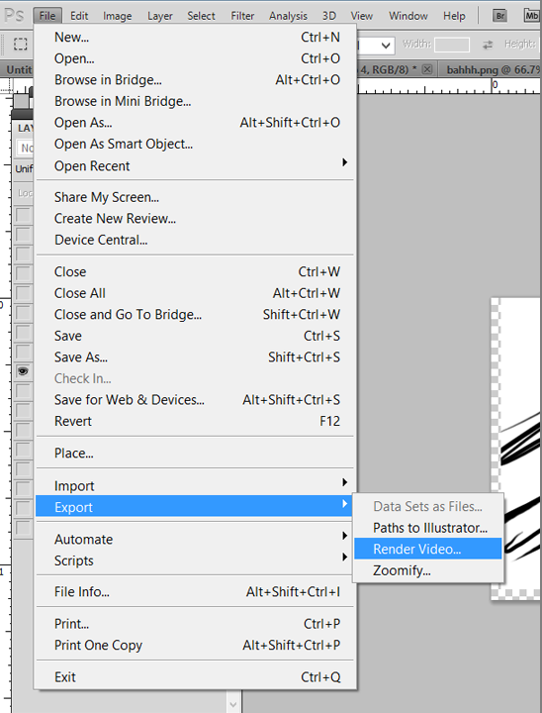

- 1) Select where you want to save out your file
- 2) Make sure you export it as a QuickTime Movie
- 3) Set frame rate to 24 FPS
- 4) Render your sequence
- And you’re DONE!

