CSE352 Spring 2015 Homework #1
Instructor: Joshua Smith TA: Hanchuan Li
Due Online in Catalyst Dropbox 4/10/2015
Homework will be graded on both effort and correctness. If you find yourself having trouble with a problem, write down what you know and how far you were able to get to get partial credit. Solutions that are correct but do not adequately explain the question may not receive full credit. Solutions that are incorrect and show no work will not receive any credit.
You are encouraged to collaborate with your peers. However, each person must write up their homework assignments individually. Justice will be enforced if you are caught cheating. If you need an extension, you are required to submit a Haiku explaining why you need an extension BEFORE the homework deadline. Late homework is subject to a late penalty of 20 percent per day.
If you have any questions, please email to ’staff cse352 15sp@cs.washington.edu’

Question 1 Power Consumption
Suppose an iPhone’s leakage current is 3mA, and supply voltage is 1.5V. When playing Angry Birds, the clock frequency is 800MHz and net capacitance is 200pF (pico Farads). (a) What is the value of the static power consumption? (b) What is the dynamic power consumption (ignoring crowbar current)? (c) What is the total power consumption?

Question 2 Truth tables
Consider the following Boolean expressions. For each expression write out the corresponding truth table.
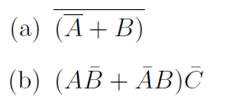

Question 3 Boolean Algebra
Ben Bitdiddle and Alyssa P. Hacker are having an argument over the equivalence of two Boolean expression (they have nothing better to do). Alyssa P. Hacker claims that the following two expressions are equivalent:
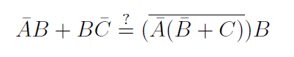
Ben Bitdiddle on the other hand disagrees and claims that they are not. Who is right? If they are equivalent, prove it using Boolean algebra. If they are not, evaluate the truth table to show that they are not equivalent.

Question 4 CMOS Circuits
For the following Boolean expressions draw the equivalent CMOS gate implementation. Clearly mark the input and output signals and do not assume you have the complements of any signals. Minimize the number of CMOS transistors used in your implementation.
